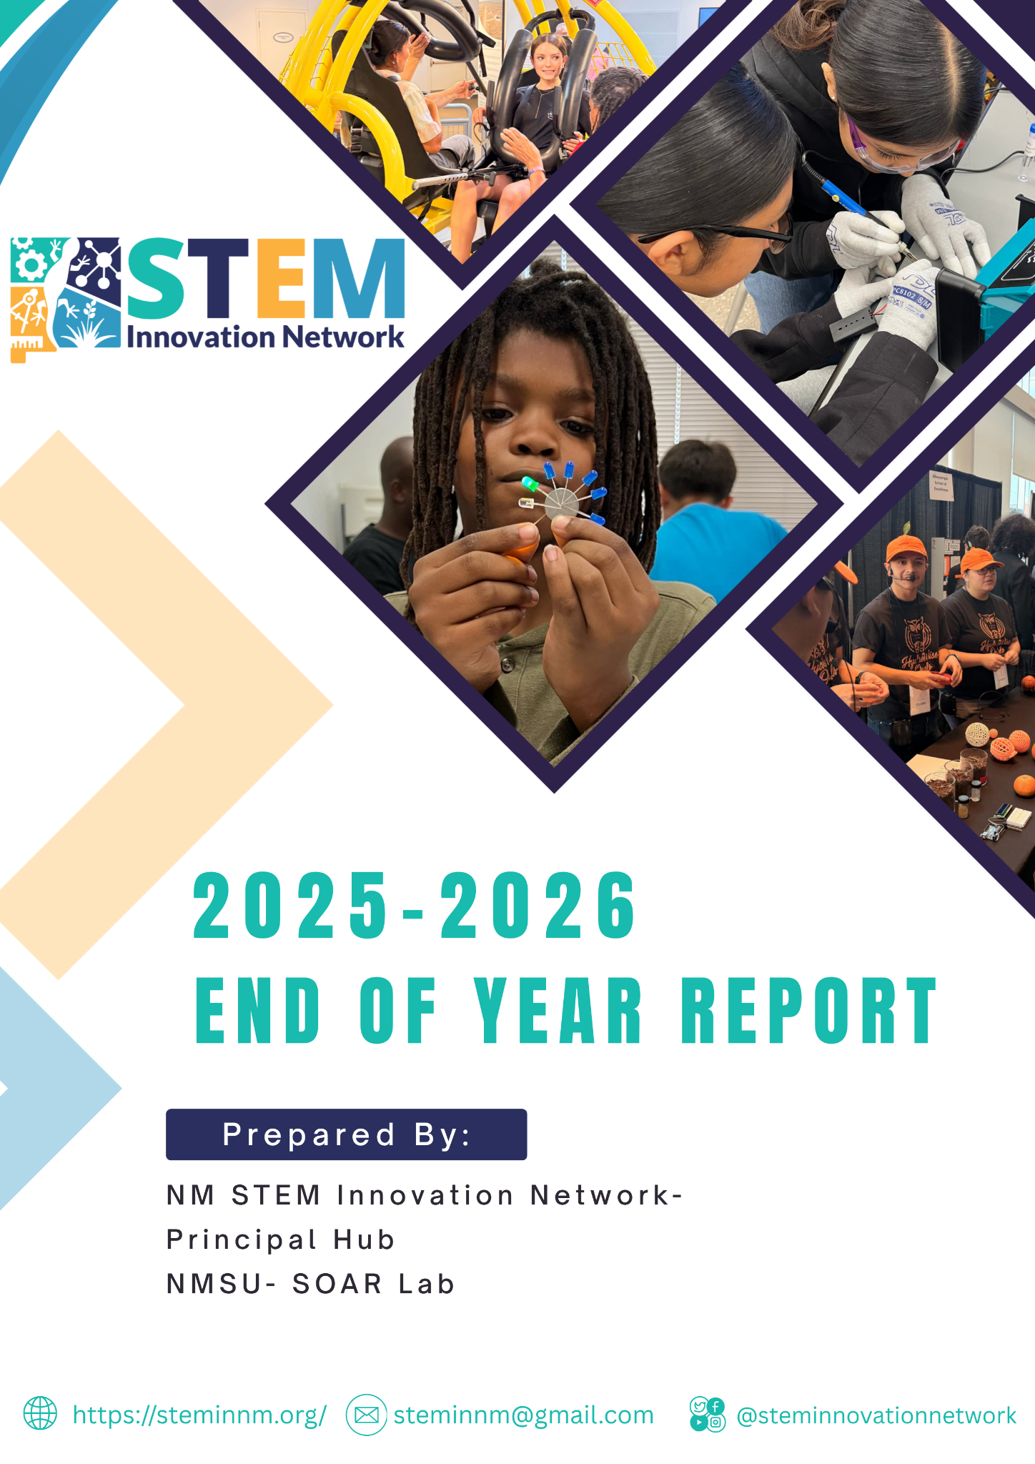
Table of Contents

- Executive Summary | Page 3
- Establishing a STEM Innovation Network for New Mexico  - STEM Action Team - Grass Roots Origin  - Principal and Regional Hub Structure  - Regional Convenings  - Establishing the Executive Council | Page 7  Page 7  Page 8  Page 9  Page 10
- Activities, Events, and Partnership Development  - Partnership Development  - Mini-grants  - Statewide Professional Learning  - Augmenting Out-of-School-Time Programming Access  - Connecting Education with Industry and Community Partners  - Supporting Statewide Competitions | Page 11  Page 11  Page 13  Page 18  Page 20  Page 24  Page 25
- Funding – Budget Expenditures and Expansion | Page 27
- Reflections from Regional Hub Directors | Page 29

1. Executive Summary
In its inaugural year, the New Mexico STEM Innovation Network transformed a long-standing vision into a coordinated statewide system for expanding STEM education and opportunity. Established through a $3 million legislative appropriation administered by the New Mexico Public Education Department (PED), the Network quickly evolved from concept to implementation. Through a Principal Hub, housed at New Mexico State University, and five Regional Hubs strategically located across the state, the Network established an infrastructure designed to strengthen inquiry-based STEM learning, expand access to high-quality out-of-school-time (OST) STEM opportunities, and better connect education with New Mexico's workforce needs. Year 1 demonstrates that the Network model is an effective approach for building regional capacity, fostering collaboration, and creating equitable STEM opportunities for students and educators throughout New Mexico.
A significant accomplishment during the first year was establishing the statewide infrastructure needed to sustain and grow the Network over time. Five Regional Hubs, anchored in higher education institutions, regional education cooperatives, and STEM-focused nonprofit organizations, received subawards to hire regional directors, convene local partners, complete regional asset maps, and develop action plans aligned with the Network's three priorities. At the statewide level, an Executive Council composed of leaders from industry, education, philanthropy, and state advisory bodies was established to provide strategic guidance and strengthen alignment with New Mexico's education and workforce priorities. Together, the Principal Hub, Regional Hubs, Executive Council, and the Network's founders created a collaborative governance structure that promotes shared leadership while allowing each region to respond to its unique strengths and needs.
The Network also demonstrated its commitment to equitable access through a statewide mini-grant program that invested nearly $274,000 in 23 innovative STEM projects across all regions of the state. These projects reached more than 2,200 students and 375 educators while prioritizing rural, Tribal, and Pueblo communities and encouraging strong partnerships among schools, higher education, community organizations, and industry. The mini-grants expanded opportunities in robotics, engineering, environmental science, coding, and other STEM disciplines while helping students develop confidence as problem-solvers and future STEM professionals. In addition to the mini-grants, the Network purposefully addressed the following three priorities.
Priority 1: Building Educator Capacity. Developing educator knowledge and instructional practice was a central focus throughout Year 1. The Principal Hub delivered an extensive portfolio of virtual and in-person professional learning in partnership with eleven organizations, providing educators with research-based strategies in mathematics, science, engineering, artificial intelligence, makerspaces, outdoor learning, and STEM pedagogy. Extended mathematics institutes, communities of practice, book studies, and statewide webinars reflected the Network's commitment to sustained professional learning rather than one-time workshops. Regional Hubs complemented these statewide efforts by designing and delivering professional learning tailored to local needs through partnerships with organizations such as Environmental Education New Mexico, NM MESA, Española Glove Works, Tech Trek, public libraries, and the Asombro Institute. Collectively, these efforts supported more than 700 educators and strengthened statewide implementation of high-quality STEM instruction aligned with current educational priorities, including Senate Bill 29.
Priority 2: Expanding Out-of-School-Time STEM Opportunities. The Network significantly increased access to engaging STEM experiences outside the traditional school day, particularly in communities that previously had limited opportunities. Regional Hubs collaborated with schools and community organizations to launch or strengthen afterschool and summer programs supported by high-quality instructional materials, educator coaching, and professional learning for OST staff. More than 700 students participated directly in Network-supported summer programs, which included STEM camps, integrated STEM and arts experiences, aviation and career technical education programs, mathematics institutes, and AP science boot camps. Innovative partnerships, including the aviation internship program with the Soules Aero-Knowledge Center, demonstrated how authentic work-based learning experiences can strengthen both technical skills and career awareness while inspiring students to pursue STEM pathways. Two regional hubs also secured three-year funding through the Community School Bureau HB2 OST grants to establish after-school STEM programs for rural communities in the southwestern and southeastern part of the state.
Priority 3: Connecting STEM Education to Workforce Pathways. Throughout its first year, the Network strengthened connections between education and New Mexico's workforce by cultivating strategic partnerships with industry, state and national organizations, and community leaders. An Industry Roundtable brought together education and industry representatives to identify shared priorities around work-based learning, equity, and regional workforce alignment. These partnerships have already generated new funding opportunities and expanded authentic career exploration experiences, internships, and industry engagement in classrooms, out-of-school-time programs, and statewide STEM competitions. Collaborations with the Encantado Foundation and Future Focused Education initiated the development of an Industry Playbook to guide meaningful partnerships between educators and employers, while relationships with national STEM organizations introduced promising practices that are now being adapted for New Mexico's unique educational and economic landscape. Together, these efforts established a strong foundation for developing coherent STEM career pathways that prepare students for high-wage, high-demand careers across the state.
Partnership-building remained both a strategy and an outcome throughout Year 1. The Network participated in more than 70 statewide and regional events, engaging educators, families, community organizations, higher education institutions, industry partners, and state agencies in a shared vision for STEM education. Regional asset mapping expanded awareness of local resources, while statewide initiatives such as the Governor's STEM Challenge & Showcase, Miner Mayhem, and the New Mexico Supercomputing Challenge broadened participation, particularly among rural, Tribal, and historically underrepresented communities. At the same time, the Network demonstrated strong fiscal stewardship by investing approximately 95 percent of its legislative appropriation while leveraging additional public and private funding to extend its reach and impact.
As the Network enters its second year, it does so with strong momentum, a robust statewide infrastructure, and an expanding network of committed partners. Lessons learned during Year 1 are informing the next phase of growth, including establishing a nonprofit foundation to support future grantmaking, integrating artificial intelligence into STEM initiatives, strengthening regional implementation through the Hub structure, and deepening connections between education and workforce development. The Network's first year clearly demonstrated that when statewide coordination is combined with strong regional leadership, authentic partnerships, and a commitment to equity, New Mexico can create meaningful STEM opportunities that prepare students for success in school, careers, and their communities. With continued investment and collaboration, the New Mexico STEM Innovation Network is well positioned to expand its impact and ensure that every student, regardless of geography, has access to high-quality STEM learning and career pathways.
Dr. Wanda Bulger-Tamez
Exec. Director, NM STEM Innovation Network

New Mexio STEM Innovation Network (STEMinNM)
Year 1 – At a Glance
Category | Year 1 Result
Legislative Appropriation | $3 million
Hubs Established | 1 Principal Hub + 5 Regional Hubs
Mini-grant Funding Awarded | $274,000
Students Reached (mini-grants) | 2,200+ Students
Educators Supported (mini-grants) | 375+ Educators
Educator Professional Learning (Overall) | 700+ Educators
Expansion of Summer OST Opportunities | 700+ Students
Statewide Regional Events | 70+ Events
Legislative Funds Invested | ~95% of the Appropriation
New Funding Secured to Expand STEM OST Programs in Years 2-4. | $1,690,000

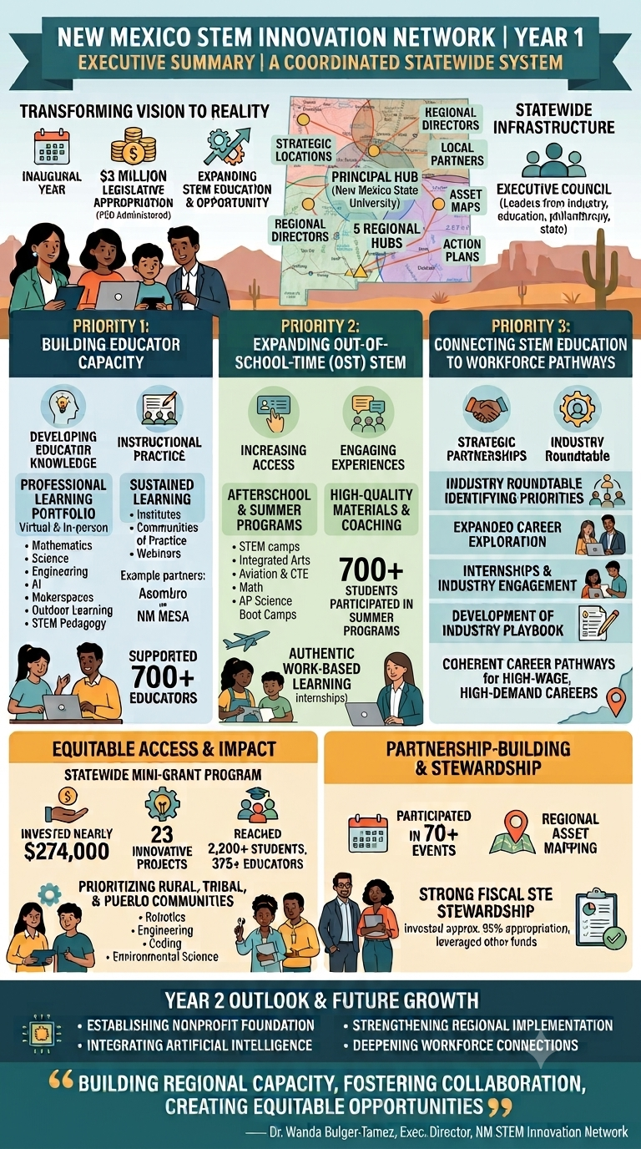

2. Establishing a STEM Innovation Network for New Mexico

Grass Roots Origin

The New Mexico STEM Innovation Network was established on July 31, 2025 through an intergovernmental agreement with the PED. Funding for the Network was allocated by House Bill 2 passed during the 2025 Legislative Session, fueled by a grass-roots advocacy campaign by the STEM Innovation Action Team. This action team was a group of STEM education advocates and included representatives from the LANL Foundation, Society of Women Engineers, TRIAD LLC/Los Alamos National Laboratory Community Partnerships, NM MESA, NMSU STEM Outreach Center, Math and Science Advisory Council (MSAC), NM Out-of-School Time Network, Encantado Foundation, STEM Boomerang, Adelante Development Center, and UNM Project Echo.

Group members began to convene in 2023 to conceptualize and advocate for a network that could ensure quality STEM learning opportunities were available to all regions and school districts regardless of geography, school district funding, and socio-economic status. In November 2024, the LANL Foundation and Encantado Foundation hosted a state-wide day-long convening of stakeholders to discuss the creation of a STEM Innovation Network for New Mexico (STEM IN NM). Over 100 people attended to learn about past and current efforts to create a STEM Innovation Network in New Mexico, to hear panels of experts speak about the need for STEM education in NM from employers and workforce development perspectives, and to learn from leaders of STEM Innovation Networks in other states. Participants also engaged in discussions to envision the work they would like to see a STEM Innovation Network accomplish in New Mexico. (Link to Nov. 2024 Partnerships Convening Report.)

The results of the grass-roots effort were legislative funds being allocated to the PED in March 2025 for the purpose of establishing the New Mexico STEM Innovation Network.

The newly established Network convened 16 education, industry, and professional learning organizations on July 30, 2025 to develop the Network’s mission to connect STEM programs and systems and establish a cohesive infrastructure that supports PreK–college STEM pathways, preparing students for STEM careers. The partners discussed the following:

- Identifying success metrics;
- Aligning with current initiatives and statewide priorities; and,
- Defining priorities for local and regional investments.
The meeting also resulted in solidifying the Network’s three priority areas to strengthen STEM education and students access to quality STEM careers in New Mexico.
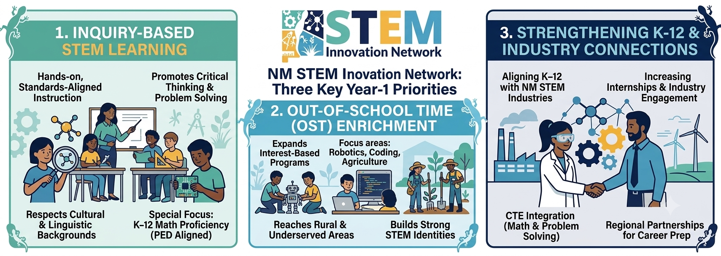
      - Inquiry-Based STEM Learning in All New Mexico K–12 Classrooms The network strengthens standards aligned and inquiry-based, hands-on STEM instruction that promotes critical thinking and problem-solving while respecting students’ cultural and linguistic backgrounds. The Network is prioritizing K–12 math proficiency in alignment with the PED goals in its first two years.
- Access to Out-of-School Time (OST) STEM Enrichment. The network expands interest-based OST STEM programs—such as robotics, coding, and agriculture, especially in rural areas. These programs improve engagement and success in school and build strong STEM identities.
- Strengthening Connections Between K-12 Education and New Mexico Industry. The network aligns K–12 education with New Mexico’s STEM industries. Key efforts include increasing internships, industry engagement, regional partnerships, and integrating math and problem-solving into CTE to prepare students for high-demand STEM careers.

Principal and Regional Hub Structure

New Mexico State University- Institute for Excellence in Math and Science Education ((NMSU- IEMSE) serves as the STEM Innovation Network Principal Hub. It was originally staffed by an Executive Director, Co-Director for STEM Professional Learning and two specialists for partnership development and out-of-school-time (OST) expansion. Through regional convenings and listening sessions, the Principal Hub established five Regional Hubs across the state. They are:

- Southwest Region: Western New Mexico University and Southwest Regional Education Cooperative (soutwesthub@steminnm.org)
- Southeast Region: Regional Education Cooperative #6 and Future Innovators Academy (southeasthub@steminnm.org)
- Northeast Region: New Mexico Highlands University (northeasthub@steminnm.org)
- Northwest Hub: San Juan College (northwesthub@steminnm.org)
- Central Region: Explora, New Mexico Tech, and R4Creating (centralhub@steminnm.org)
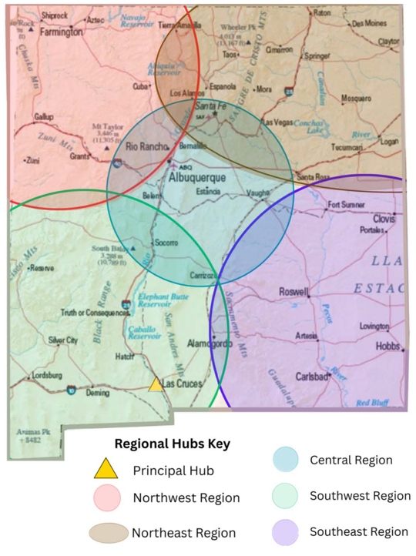
These six Hubs form a statewide network for STEM Innovation and dissemination across the four quadrants of the state and the central region. Through partnerships with Regional Education Cooperatives, higher education, Career and Technical Education programs, and New Mexico Workforce Solutions, the Hubs coordinate resources and strengthen statewide STEM connections. They share resources and best practices, promote regional STEM programs and assets, and engage industry partners to connect education with STEM careers and workforce needs.

Regional Convenings, Fall 2025

Regional Hubs were established based on information gathered at regional convenings across the state in September/October 2025 to introduce the concept of a New Mexico STEM Innovation Network, clarify statewide priorities, and begin conversations about what a regional STEM Hub could look like in each area. In order to foster collaboration and partnership, the Principal Hub invited representatives from industry, professional learning organizations, education, economic development, and workforce solutions to participate in these convenings to consider regional assets, areas of need, and potential action steps in relation to the Network priorities. These day-long meetings resulted in the participants identifying unique regional plans to support STEM teaching, learning, and career pathways, and which agency or agencies were best suited to lead the regional hub efforts. The convenings concluded with concrete next steps and action plans, including potential hub locations, leadership structures (e.g., Regional Director roles), and early ideas for programming, professional development, and ongoing stakeholder gatherings to sustain regional collaboration

A lead fiscal agent was identified in each of the five regions and the Regional Hubs were established in November 2025. Each Regional Hub received a subaward of $250,000 to hire a regional director and begin to formalize partnerships within the regions to address the Network priorities. The hub directors met weekly with the Principal Hub beginning in December 2025 to establish a reporting structure, identify actions to be completed in each region, and to build a support system for coordinating inquiry-based STEM teaching and learning, expand high-quality OST STEM enrichment in rural and Tribal communities, and strengthen connections between PK-12 systems and NM’s STEM Industries and workforce pathways.

Establishing an Executive Council

The Executive Council (EC) was established in the first year of the Network and serves as an advisory body to guide the vision, priorities, funding recommendations, and strategic direction of the New Mexico STEM Innovation Network. In line with the three Network priority areas, the EC has membership from different groups who have perspectives and experience in areas such as industry pathways, out of school time, and K-12 education. Executive Council members are listed in the following table.

Members of the NM STEM Innovation Network Executive Council
Name | Organization
Marcellus Davis (Co-Chair) | NMOGA- Director of Community Engagement & Education
Erika Genty (Co-Chair) | NMSU Global and Workforce Dev. Council
Avelina Borrego | Economic Development Council
Frank Sanchez | Career & Technical Education Statewide Advisory
Geraldine Garrity | Indian Education Act Advisory Council
Carolyn (Cari) Hushman | NM Math and Science Advisory Council (UNM)
Nathan (Nate)Tohtsoni | Navajo Transitional Energy
Kathy Keith | Los Alamos National Labs
TJ Parks | Maddox Foundation
David Chavez | Cooperative Education Services
Milo McMinn | Farmington Public Schools
Dale Dekker | DPS Architecture and Design
Ryan Labbe | Tyler Technology
Jan Williams | Society of Women in Engineering

Executive Council Meeting Schedule in Year 1

- The Executive Council initial meeting was December 3, 2025 (via Zoom) to introduce the council members to the STEM Innovation Network. The council also reviewed and provided feedback on the newly drafted strategic plan to Network staff. (Link to Year 1 Strategic Plan condensed format.)
- The council met in person on April 9, 2026, after the Industry Roundtable to compile suggestions and consider next May 5, 2026, steps information from the Roundtable discussions.
- The EC met via Zoom on as a follow-up to the April 9 Roundtable. We reviewed reports generated by the Industry Roundtable and the Executive Council structure. The council determined that two working groups were needed to (1) develop a clear working structure and Charter for the council and (2) narrow the priority areas that were generated by the Industry Roundtable. (Link to Industry Roundtable Summary Report.) These working groups met between May 5th and May 27th to work on their objectives.
- The EC met on May 27, 2026, to share the action steps from the working groups.
  - The “Process” subgroup shared a draft of the Executive Council Charter which included the decision-makes process, terms of membership, and suggested meeting schedule. The committee opted to meet four times each year - two in-person and two virtual meetings. Two co-chairs were also nominated for the Executive Council. (Link to the Executive Council Charter.)
  - The “Priorities” subgroup narrowed a long list of priorities to call to action for the Executive Council and Network staff:
    - Infrastructure: Develop an adaptable pathway guidebook with aligned opportunities.
    - Student Guidance: Connect students to industry and workforce opportunities while understanding their interests.
    - Statewide Awareness: Strengthen communication and awareness across New Mexico.
    - Communication Alignment: Promote aligned messaging that builds STEM identity and highlights multiple education and career pathways.
    - Career Readiness: Increase industry return on investment by strengthening career readiness.
In subsequent years the Executive Council will continue to refine priorities and guide the Network’s strategic direction. Together, this regular meeting structure keeps the Network responsive, connected, and focused on delivering high-quality, equitable STEM opportunities statewide.

3. Partnership Development, Activities, and Events

Partnership Development

During the 2025–2026 school year, the NM STEM Innovation Network strengthened statewide collaboration by building partnerships that connected education, higher education, industry, libraries, community organizations, and state agencies. The NM STEM Innovation Network supported and participated in 70+ events, professional learning opportunities, regional convenings, and community partnerships across New Mexico.

Regional partnerships developed or initiated in Year 1, include Math Amigos, ASCEND, Steady State, and Math Circles. Statewide collaborations included Teach Plus, Los Alamos National Laboratory (LANL), ROSE at the University of New Mexico, the New Mexico Science Teachers Association (NMSTA), NMEXL, New Mexico MESA, Project ECHO, Computer Science initiatives, the Math and Science Academy (MSA), CIRCLES, EPSCoR, the Good Future Project, UNM STEM, and the Office of the Vice President for Research at the University of New Mexico.

The Network also expanded access to STEM learning through partnerships supporting STEM learning labs, makerspaces, and community STEM infrastructure at the Hobbs, Roswell, and Ruidoso Public Libraries, Hobbs Head Start, Kids' Space, and the STEM Outreach Center. In addition, the Network collaborated with partners through presentations and engagement at the NMSTA Conference, CES Leadership Conference, and the New Mexico Out-of-School Time (NMOST) Conference.

Collectively, these partnerships strengthened regional collaboration, expanded access to high-quality STEM learning opportunities, and advanced a connected, sustainable STEM ecosystem for students, educators, families, and communities across New Mexico.

Senate Bill 29 Partnership Convenings

The NM STEM Innovation Network convened two Math Bill 29 Partnership meetings on April 30 and May 14, 2026, bringing together state, district, higher education, and nonprofit partners to support coordinated implementation of Math Bill 29. Participants included the Math and Science Bureau, Math and Science Academy (MSA), Los Alamos National Laboratory (LANL), Teach Plus, Project ECHO, Albuquerque Public Schools (APS), Gadsden Independent School District, Regional Education Cooperative 6 (REC 6), New Mexico Tech, CES, and Mathematically Connected Communities Project (MC²).

Through these convenings, partners collaborated to align statewide efforts and developed a shared logic model to guide implementation, strengthen coordination, and support high-quality mathematics instruction across New Mexico. (Link to the Logic Model.)

CTE Consortium

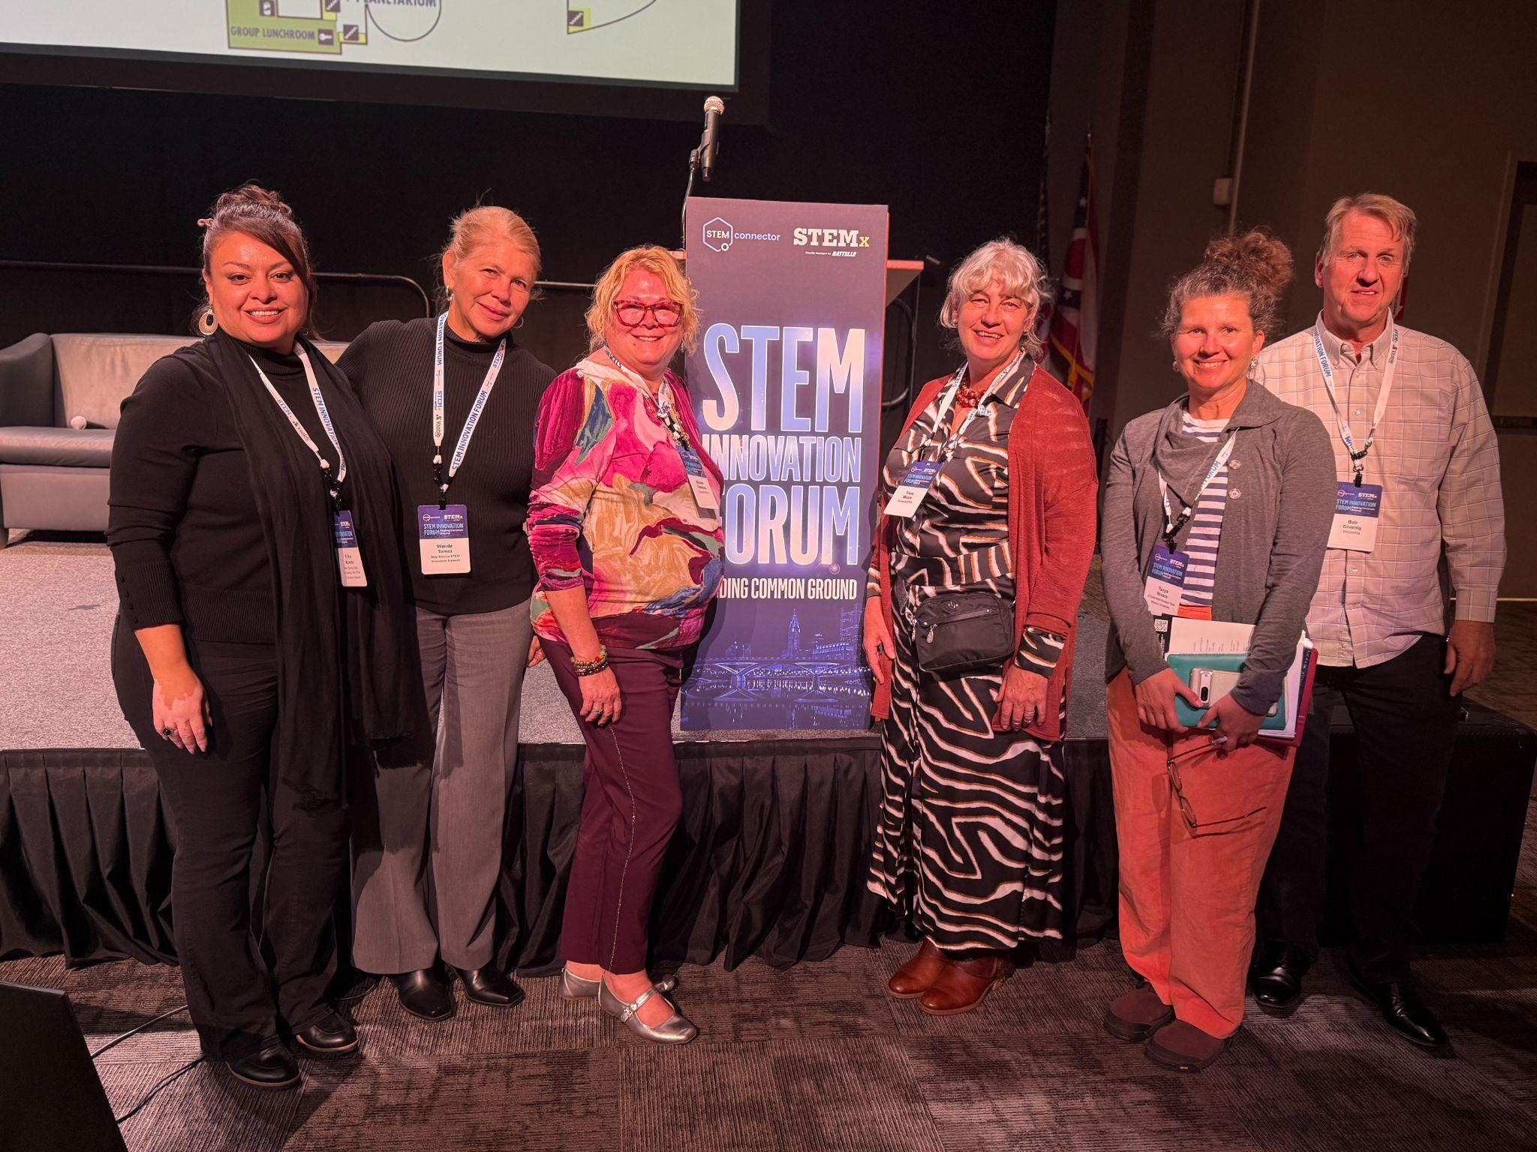
The Network staff is also collaborating with Cooperative Education Services (CES) to build a consortium of rural school districts to expand and coordinate Career and Technical Education (CTE) pathways in rural schools. Currently, rural schools have limited CTE offerings due to staffing, connection to post-secondary institutions that can provide dual credit options for students, and access to internship opportunities. The consortium began monthly meetings in June 2026 and has designated working groups to address these barriers by the 2027-2028 school year.

National Partnerships

National partnerships expanded the Network's reach by collaborating with organizations across the country. Key partners included STEMX, the Ohio STEM Network, the Louisiana STEM Network, the Tennessee STEM Network, Great Minds, Battelle Education, the Good Future Project (Yale University), Community Share, and ExcelinEd.
STEMinNM Directors Meet with Ohio STEM
Network partners.

2025-26 Mini-grants

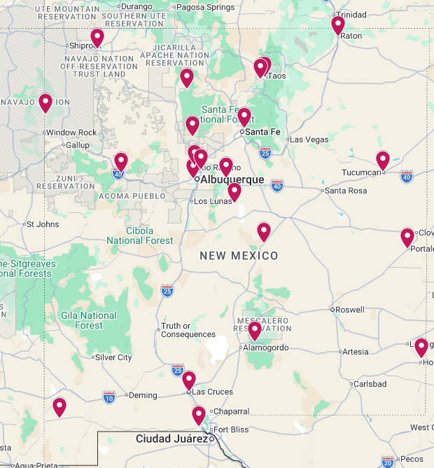
Year 1 of the New Mexico STEM Innovation Network mini-grants marked a significant first step towards building a cohesive PreK- college STEM infrastructure aligned with the PED priorities. Nearly $274,000 in funding was awarded to 23 schools, districts, community organizations, and higher education and industry partners across six geographic regions (see map for 25-26 awardees), of which 21 awardees accepted the funding. Collectively, these grantees expanded access to both in-school and out-of-school STEM learning for over 2,200 students and provided professional learning and coaching for about 375 educators. Consistent with the Network’s pillars to build capacity, foster collaboration, and strengthen STEM identities and readiness, priority was placed on projects that formed cross-sector partnerships, reached historically underserved rural, Tribal, and Pueblo communities, and connected students to high-wage, high-demand STEM careers.
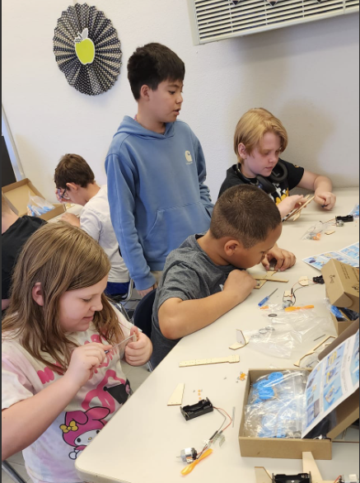
The funded projects strongly advanced inquiry-based and culturally responsive STEM learning, with a particular emphasis on mathematics. Initiatives such as MathAmigos focused on sustained, innovative professional development to help teachers inspire a love of math and deepen mathematical reasoning in K-12 classrooms, while AgriMath NM used robotics, drones, and AI-powered agriculture projects to connect quantitative skills to real-world rural challenges. Several projects integrated traditional and Indigenous knowledge. For example, blending traditional Diné mathematical concepts and land-based learning with contemporary standards to create authentic problem-solving experiences for Native students. Educators reported that, through these efforts, they gained new ideas for hands-on STEM activities, better understood STEM and career pathways in New Mexico, and felt more confident preparing students for further education and careers, often sharing materials and strategies with colleagues to extend impact.
Raton OST Cyber Security, AI, and Robotics

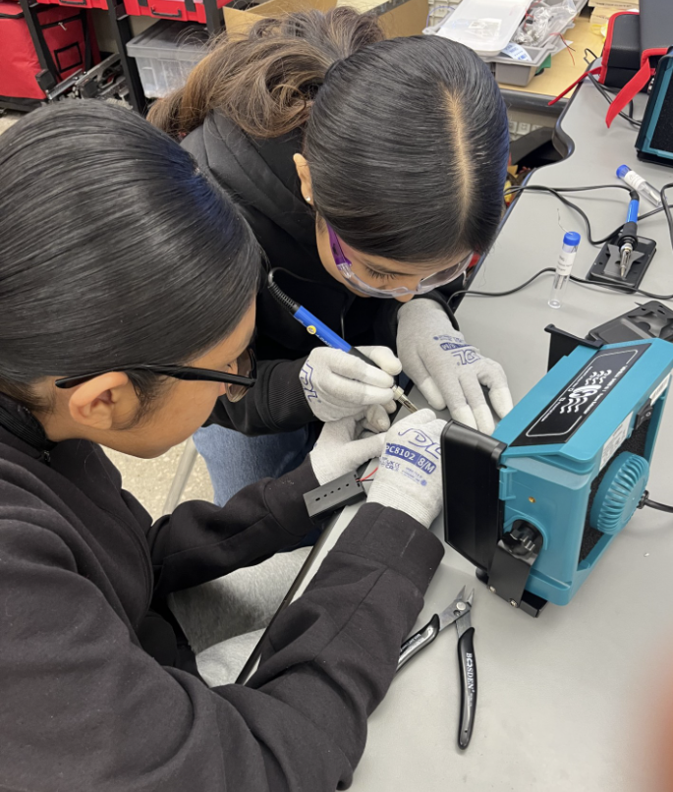
Out-of-school time (OST) enrichment emerged as a major strength of the portfolio, with projects such as after-school makers clubs and a Makers Faire at Edgewood Middle School; expanded STEAM and electric car clubs at Taos Middle School; and new OST offerings in coding, cybersecurity, AI, robotics, and fabrication through groups like El Raton Media Works and Cruces Creatives. Students described their favorite parts of these programs as “getting to be hands on,” “learning new things, and getting to create different things,” launching rockets after overcoming last-minute design challenges, visiting museums and STEM expos they otherwise could not access, and presenting to younger students and watching them problem-solve. These experiences helped students see themselves as scientists and engineers and sparked lasting skills they plan to carry forward—leadership, time management, teamwork, communication, critical thinking, and even specialized knowledge such as plant care, water quality testing, and microbiology techniques.
Metal Matters
Finally, the mini-grants made notable progress in strengthening connections between K-12 education and New Mexico’s STEM industries and career pathways. Projects created clear pipelines through aerospace-focused CTE programs culminating in student-designed rocket launches and NASA-connected experiences, soldering and fabrication projects that introduce trades and technical careers, healthcare simulations and engineering design challenges, and work-based learning models that mirror industry tools and expectations. Both students and teachers highlighted how these opportunities built confidence and revealed new futures: students reported gaining skills “critical for my future careers” and learning they could “teach other people and still have fun,” while educators emphasized watching hesitant learners become active investigators and problem-solvers with robotics, coding, drones, and environmental science. Across rural, Tribal, and Pueblo robotics and engineering programs, community-centered STEM events, and new maker spaces in schools and apartment communities, the Year 1 mini-grant cycle demonstrated how targeted, collaborative investments can transform passive learning into active investigation, expand access and relevance, and begin to prepare New Mexico students for meaningful, future-ready STEM careers.

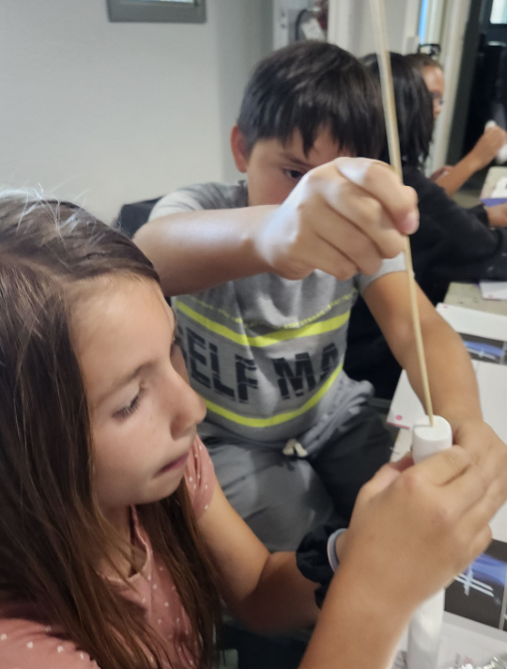
Mini-Grants Key Lesson and Next Steps
STEM with an A

The first year of mini-grants laid a strong foundation for the Network’s ongoing work by showing that relatively small, well-targeted investments, grounded in cross-sector partnerships and local assets, can catalyze meaningful, scalable change. Key lessons include the following:
- the value of sustained professional learning (rather than one-time workshops),
- the power of cultural and community-responsive design in engaging rural, Tribal, and Pueblo learners,
- the importance of integrating mathematics and STEM identity-building into both classrooms and OST settings, and
- understanding the challenges of small schools and organizations that lack sufficient capital to cover project costs upfront and await reimbursement.

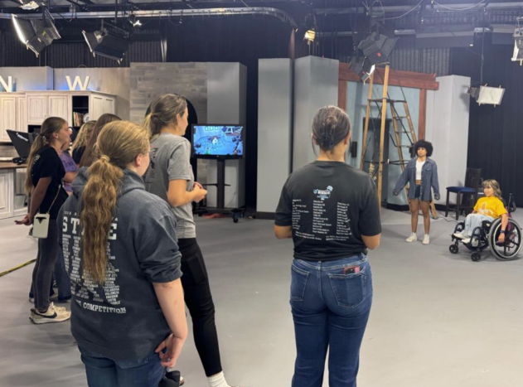
These insights will guide future grantmaking and Network initiatives, shaping how resources are braided, how partnerships are structured, and how promising models, such as integrated agriculture-and-math programs, AI-focused projects, robotics and maker spaces, and career-connected OST clubs, are supported, refined, and scaled. In alignment with state, national, and global efforts to increase AI awareness and address misconceptions about AI in education and the workplace, the 2026–27 mini-grants will intentionally encourage the incorporation of AI literacy, tools, and innovation to ensure students develop the skills needed to remain competitive and meet 21st-century workforce demands.
Future Ready and Dream Academy

List of 2025-26 Mini-grants

Mini-grant Project Name  Organization  Community Served | Priority Area  Audience served | Project Description
MathAmigos: Teaching Math – A New Direction for Professional Development  Math Amigos  Santa Fe, NM | High-Quality Mathematics Instruction  4 workshops for 50 teachers each; given that each teacher impacts impacting 4000+ students | MathAmigos provides sustained professional development that equips teachers with innovative strategies to inspire students to enjoy and succeed in mathematics.
Water Wise Teens: Municipal Quality & Conservation Lab  STEM is Childs Play Foundation  Rio Rancho, NM | Strengthened Connections to Industry  50 9th graders, 10 educators, and community members who participated in the community fair | Students investigate municipal water quality, apply math and science skills to analyze findings, and develop practical conservation solutions for their schools and community.
STEM Pathways for All: Connecting Students to Innovation and Careers  Lincoln Middle School STEM Club  Rio Rancho, NM | Establish or expand informal STEM Out-of-School-Time Programming  52 middle students, 6 educators | The project connects middle school students with scientists and authentic research experiences to build curiosity, collaboration, and mathematical reasoning.
EMS Makers Program  Edgewood Middle School  Moriarty & Edgewood, NM | Establish or expand informal STEM Out-of-School-Time Programming  40-50 middle school students, and 6 educators | The project establishes an after-school Makers Club and a Spring 2026 Makers Fair while expanding makers-themed classroom lessons, activities, and guest speakers.
AgriMath NM: Cultivating STEM in Rural Communities  Estancia Municipal Schools  Estancia, NM | High-Quality Mathematics Instruction  600 students - Between 2 Districts  and 75 educators- Between 2 Districts | AgriMath NM is a two-district, math-integrated STEM initiative using robotics, drones, and AI-powered agriculture projects to engage rural students in hands-on problem solving.
STEM with an "A" to include the Arts  Northwest New Mexico Arts Council  Farmington, NM | Establish or expand informal STEM Out-of-School-Time Programming  600+ student conference participants and 10+ educators | The project introduces STEAM careers through OST programs, industry mentorship, and high-quality mathematics professional development and instruction.
Expanding Rural STEM Opportunities at Taos Middle School  Taos Middle School  Taos, NM | Establish or expand informal STEM Out-of-School-Time Programming  150 students and 8 educators | The project expands Taos Middle School’s OST STEAM and Electric Car Clubs by connecting rural and underrepresented students with STEM competitions and industry professionals.
Raton OST Cyber Security, AI & Robotics  El Raton Media Works Inc.  Raton, NM | Establish or expand informal STEM Out-of-School-Time Programming  24 middle and high school students and 2 educators | Out-of-school STEM programs in coding, cybersecurity, AI, and robotics build technology and problem-solving skills while introducing students to future STEM careers.
Diamondback STEM  Diamondback STEM Tucumcari High School  Tucumcari, NM | Establish or expand informal STEM Out-of-School-Time Programming  20 high school students and 3 educators | The project expands inquiry-based, student-centered learning by preparing and mentoring teams for STEM competitions throughout the school year.
Strengthening Connections to Trades Education Through MC3 Hands-On Instruction  UNM Taos CTE Department  Taos, NM | Strengthened Connections to Industry  35-50 students and 5 educators | The project creates career pathways for rural and tribal high school students through hands-on trades training.
Metal Matters: Soldering your way to a Welding Career.  Grants Cibola County Schools  Grants, NM | Strengthened Connections to Industry  85-100 students per semester and 2-3 educators | The project provides hands-on soldering experiences that build foundational skills, spark interest in welding and trades, and connect students to career pathways.
Code the Circuit, Power the Sky: WHCS Innovation in Motion  Walatowa High Charter School  Jemez Pueblo, NM | Establish or expand informal STEM Out-of-School-Time Programming  30 high school students and 4 educators | The project equips rural Native American students with coding, robotics, and engineering design skills rooted in culture and community.
Diné Mathematical Reasoning Through Land and Culture  DZIŁ DITŁ'OOÍ SCHOOL OF EMPOWERMENT, ACTION AND PERSEVERANCE  Navajo, NM | High-Quality Mathematics Instruction  60 middle and high school students and 4 educators | The project integrates traditional Diné mathematical concepts with contemporary mathematics standards through land-based learning and authentic problem-solving.
Launching Futures with Rural Rockets  Jemez Mountain Public Schools  Gallina, NM | High-Quality Mathematics Instruction  Directly- 11 high school students, indirectly 100+ students, families, and community members | The project creates a sustainable Engineering CTE pathway where students design, build, and launch a SystemsGo rocket, connecting students to aerospace careers through NASA experiences.
STEM Sparks: Permanent Maker Spaces for Family Engagement and Innovation  Future Innovators Academy  Hobbs, NM | Establish or expand informal STEM Out-of-School-Time Programming  150-180 students and 10-15 educators | The project creates three permanent Maker Spaces in Hobbs apartment communities that provide hands-on STEM learning through Navigator-led sessions and monthly family events.
Future Ready & Dreaming High  Eastern New Mexico University  Portales, NM | Strengthened Connections to Industry  200 students and 70 educators | The event connects students and schools with industry partners through hands-on STEM activities and career readiness experiences that inspire high-demand career pathways.
Cloudcroft TSA  Cloudcroft High School TSA (Technology Student Association)  Cloudcroft, NM | Establish or expand informal STEM Out-of-School-Time Programming  40 students and 3 educators | The project improves equitable access to STEM by recruiting and retaining rural students in after-school and summer project-based STEM activities.
AgriMath NM: Cultivating STEM in Rural Communities  Corona Public Schools  Corona, NM | High-Quality Mathematics Instruction  600 students (Combination of 2 Districts) and 75 educators (Combination of 2 Districts) | AgriMath NM is a two-district, math-integrated STEM initiative using robotics, drones, and AI-powered agriculture projects. It engages rural students in hands-on problem solving.
STEM OST at Cruces Creatives Makerspace  Cruces Creatives  Las Cruces, NM | Establish or expand informal STEM Out-of-School-Time Programming  34 students | The project expands STEM out-of-school programming at the Cruces Creatives makerspace through project-based learning with makers and industry tools.
Animas STEMinNM  Animas Public Schools  Animas, NM | Strengthened Connections to Industry  116 students and 4 educators | Animas STEMinNM expands project-based STEM learning in middle school while strengthening STEM-related work-based learning opportunities for high school students.

Professional Learning Statewide

During the 2025–2026 school year, the NM STEM Innovation Network provided and supported a comprehensive portfolio of professional learning opportunities that strengthened educator capacity and advanced high-quality STEM education across New Mexico. Through virtual and in-person professional development, statewide convenings, and collaborative partnerships, the Network expanded access to evidence-based instructional practices while fostering collaboration among educators, higher education, industry, libraries, community organizations, and state agencies. These efforts supported the Network's priorities of strengthening STEM education, increasing student access, and building sustainable systems that prepare students for future STEM opportunities.
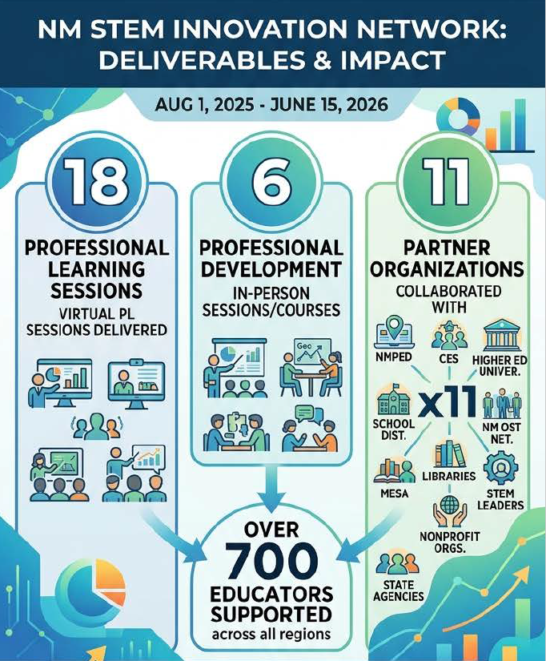
The graphic below shows year 1 impact and reach:
The 18 virtual sessions included professional learning on the New Mexico Math Framework 2.0, Math Textbook Adoption for elementary and secondary educators, the Northern STEAM Framework, Growth Mindsets, NUMeROS, Teaching All Subjects Through Science, Exploring the World of AI, Accessible Career Curriculum, Math Circles, STEM advocacy, and Senate Bill 29. The Network also hosted five virtual Connecting sessions focused on STEM trailers, STEM competitions, STEM professional development providers, STEM camps, and Growing Language Through Science. In addition, educators participated in a six-session virtual book study with Judy Reinhartz and a six-session NMPED Math Lab Community of Practice that fostered ongoing collaboration and instructional improvement.
The six in-person professional development sessions/courses included Math Textbook Adoption workshops in Albuquerque and Farmington, Geo Stats professional learning sessions in Ruidoso and Farmington, Intergrow (Add+Vantage Numeracy Foundations) professional development sessions in Farmington and Truth or Consequences, and the Inspire Math Confidence Conference.
The Network also supported and provided high-quality professional learning through the Regional Hubs in mathematics, science, engineering, makerspaces, outdoor learning, and STEM instruction through the Inspire Math Confidence Conference, Math Circles, the Ambitious Science Teaching Institute, Environmental Education of New Mexico Outdoor Education, STEM Outreach Professional Learning, Makerspaces & Renewable Energy Workshops, Española Glove Works Professional Development, NM MESA Teacher Training, Silver AP Science Bootcamp, Computer Science Alliance Summer Institute, and planning and implementation support for Senate Bill 29.
Collectively, these professional learning opportunities supported over 700 educators, strengthened instructional practice, supported statewide implementation of key educational initiatives, expanded collaboration through strategic partnerships, and advanced the NM STEM Innovation Network's mission to build educator capacity and improve STEM learning opportunities for students across New Mexico.
In Addition to virtual and regionally situated professional learning, the Network partnered with state agencies to support professional learning for educators and school/district leaders:
- The Network sponsored the keynote speaker for the Cooperative Educational Services (CES) Leadership Conference, held October 15–16, 2026, in Albuquerque. The keynote address, delivered by Dr. Kevin Fleming, focused on creating relevant educational experiences aligned with career pathways to ensure that all students enter the workforce with clarity and confidence. The conference also featured a presentation on the STEM Innovation Network model to increase awareness of its mission and statewide initiatives. Approximately 60 district superintendents and school leaders from across New Mexico attended the keynote session.
- The New Mexico Science Teachers Association partnered with the Network to support teacher registration and travel expenses for the state conference. The Network also organized conference sessions highlighting STEM-based out-of-school-time (OST) programs and hosted information sessions to raise awareness of the professional learning opportunities available through the Network.
- The New Mexico Out-of-School Time Spring 2026 Conference, co-sponsored by the Network, highlighted the importance of STEM learning in out-of-school-time (OST) settings. The conference keynote, delivered by Agnes Chavez of STEMarts Lab in Taos, explored the intersection of art, technology, science, and identity, inspiring participants to build stronger community connections by partnering with local organizations to enrich student learning. The Network also presented multiple conference sessions and hosted an information table to promote engaging STEM curriculum and resources for OST programs.
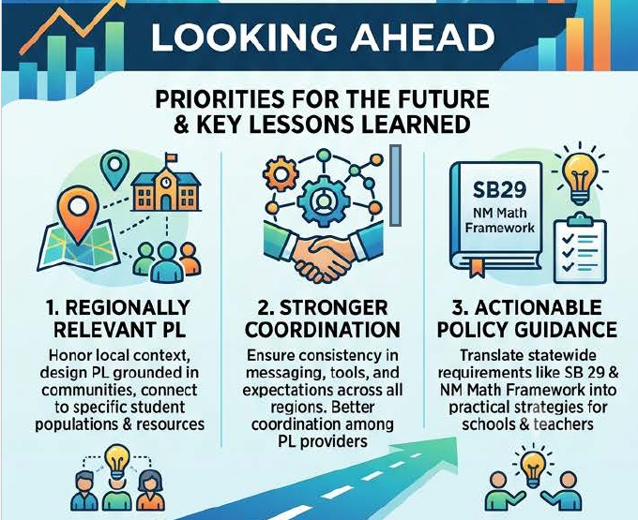
Looking Forward: During the first year of implementation, several important lessons emerged about how to design professional learning that truly meets educators’ needs and supports consistent, high-quality STEM instruction statewide. Teachers repeatedly emphasized the value of professional learning that is locally grounded, offered in or near their own communities, connected to their specific student populations, and tailored to the resources and constraints of their schools. At the same time, the breadth of offerings underscored the need for stronger coordination among providers and clearer structures to ensure consistency in messaging, tools, and expectations across all regions. Finally, as new state initiatives and mandates, such as the New Mexico Math Framework 2.0, Math Textbook Adoption, and Senate Bill 29, rolled out, educators expressed a need for more explicit, practical guidance on what these policies mean for their daily practice. Going forward, the Network will prioritize regionally relevant, well-coordinated professional learning that both honors local context and clearly translates statewide requirements into actionable strategies for schools, districts, and individual teachers.

Augmenting Out-of-School-Time Programming Access

In 2025-26, the NM STEM Innovation Network strategically expanded out-of-school-time (OST) STEM programming to rural and Tribal communities that previously had little or no access to STEM-focused opportunities. Working closely with districts and community partners, the Network helped launch and strengthen afterschool and summer STEM programs in communities such as Cliff, Animas, Silver City, and other sites identified in regional partner reports, as well as through new collaborations with organizations like Explora at Anton Chico.

This expansion followed a dual strategy:
- Establishing STEM OST where none existed: The Network worked with rural and Tribal schools to stand up new STEM-rich OST offerings in areas that had traditionally lacked dedicated STEM programming. This included site visits, co-planning with local leaders, and aligning activities with community interests and cultural contexts.
- Leveraging and enhancing existing programs: Where OST programs already existed, the Network provided STEM curriculum, hands-on kits, and direct implementation support so programs could add or deepen STEM components without overburdening staff.
2026 Summer STEM opportunities for K-12

A core element of this work was the distribution of high-quality STEM kits, such as “Careers in STEM” and “NASA Astro”, along with coaching and professional learning for OST staff and classroom teachers who were implementing them for the first time. Network staff and partners supported educators with lesson modeling, pacing guides, and troubleshooting, helping build confidence among teachers and paraprofessionals who did not see themselves as “STEM experts.”
By combining materials, technical assistance, and relationship-based support, the Network enabled more rural and Tribal schools, libraries, and community organizations to offer consistent, engaging STEM experiences after school and in summer. This support helped K- 6 programs run one-week camps that combined hands-on activities with career awareness. Schools and organizations using these kits included Las Vegas City Schools, Na’ Neelzhiin Ji Olta’ and Cuba Independent Schools, Jefferson Montessori Academy in Carlsbad, RTS Learning Foundation in Hobbs, Mountainair Public Schools, Sidney Gutierrez Elementary in Roswell, Truth or Consequences Elementary, Sierra Elementary, Northern NM ROC Foundation/Chama Valley Schools, and the NMSU STEM Outreach Center. 450 students participated in the STEM Careers and Astro Camps.
This approach not only broadened geographic access but also strengthened the capacity of local educators and program leaders to sustain and grow OST STEM opportunities in their own communities.

The Regional Hubs also partnered with a broad set of institutions to coordinate summer programming that blended STEM with arts, CTE, social-emotional learning, and academic support.
- The Southwest Hub provided week-long STEM summer camps at school sites for elementary and middle schools in Silver City and Cliff and an Advanced Placement Science bootcamp for high school students. The SW Hub also hosted community technology camps through a community partnership with Future Forge. Approximately 300 students participated in these week-long camps.
- The Northwest Hub partnered with NM MESA and Tierra y Montes Soil and Water Conservation District to provide extended summer STEM camps to over 150 students living in rural communities .
Collectively nearly 1000 students gained access to summer STEM camps in2026 as a result of the Network efforts.
Internships

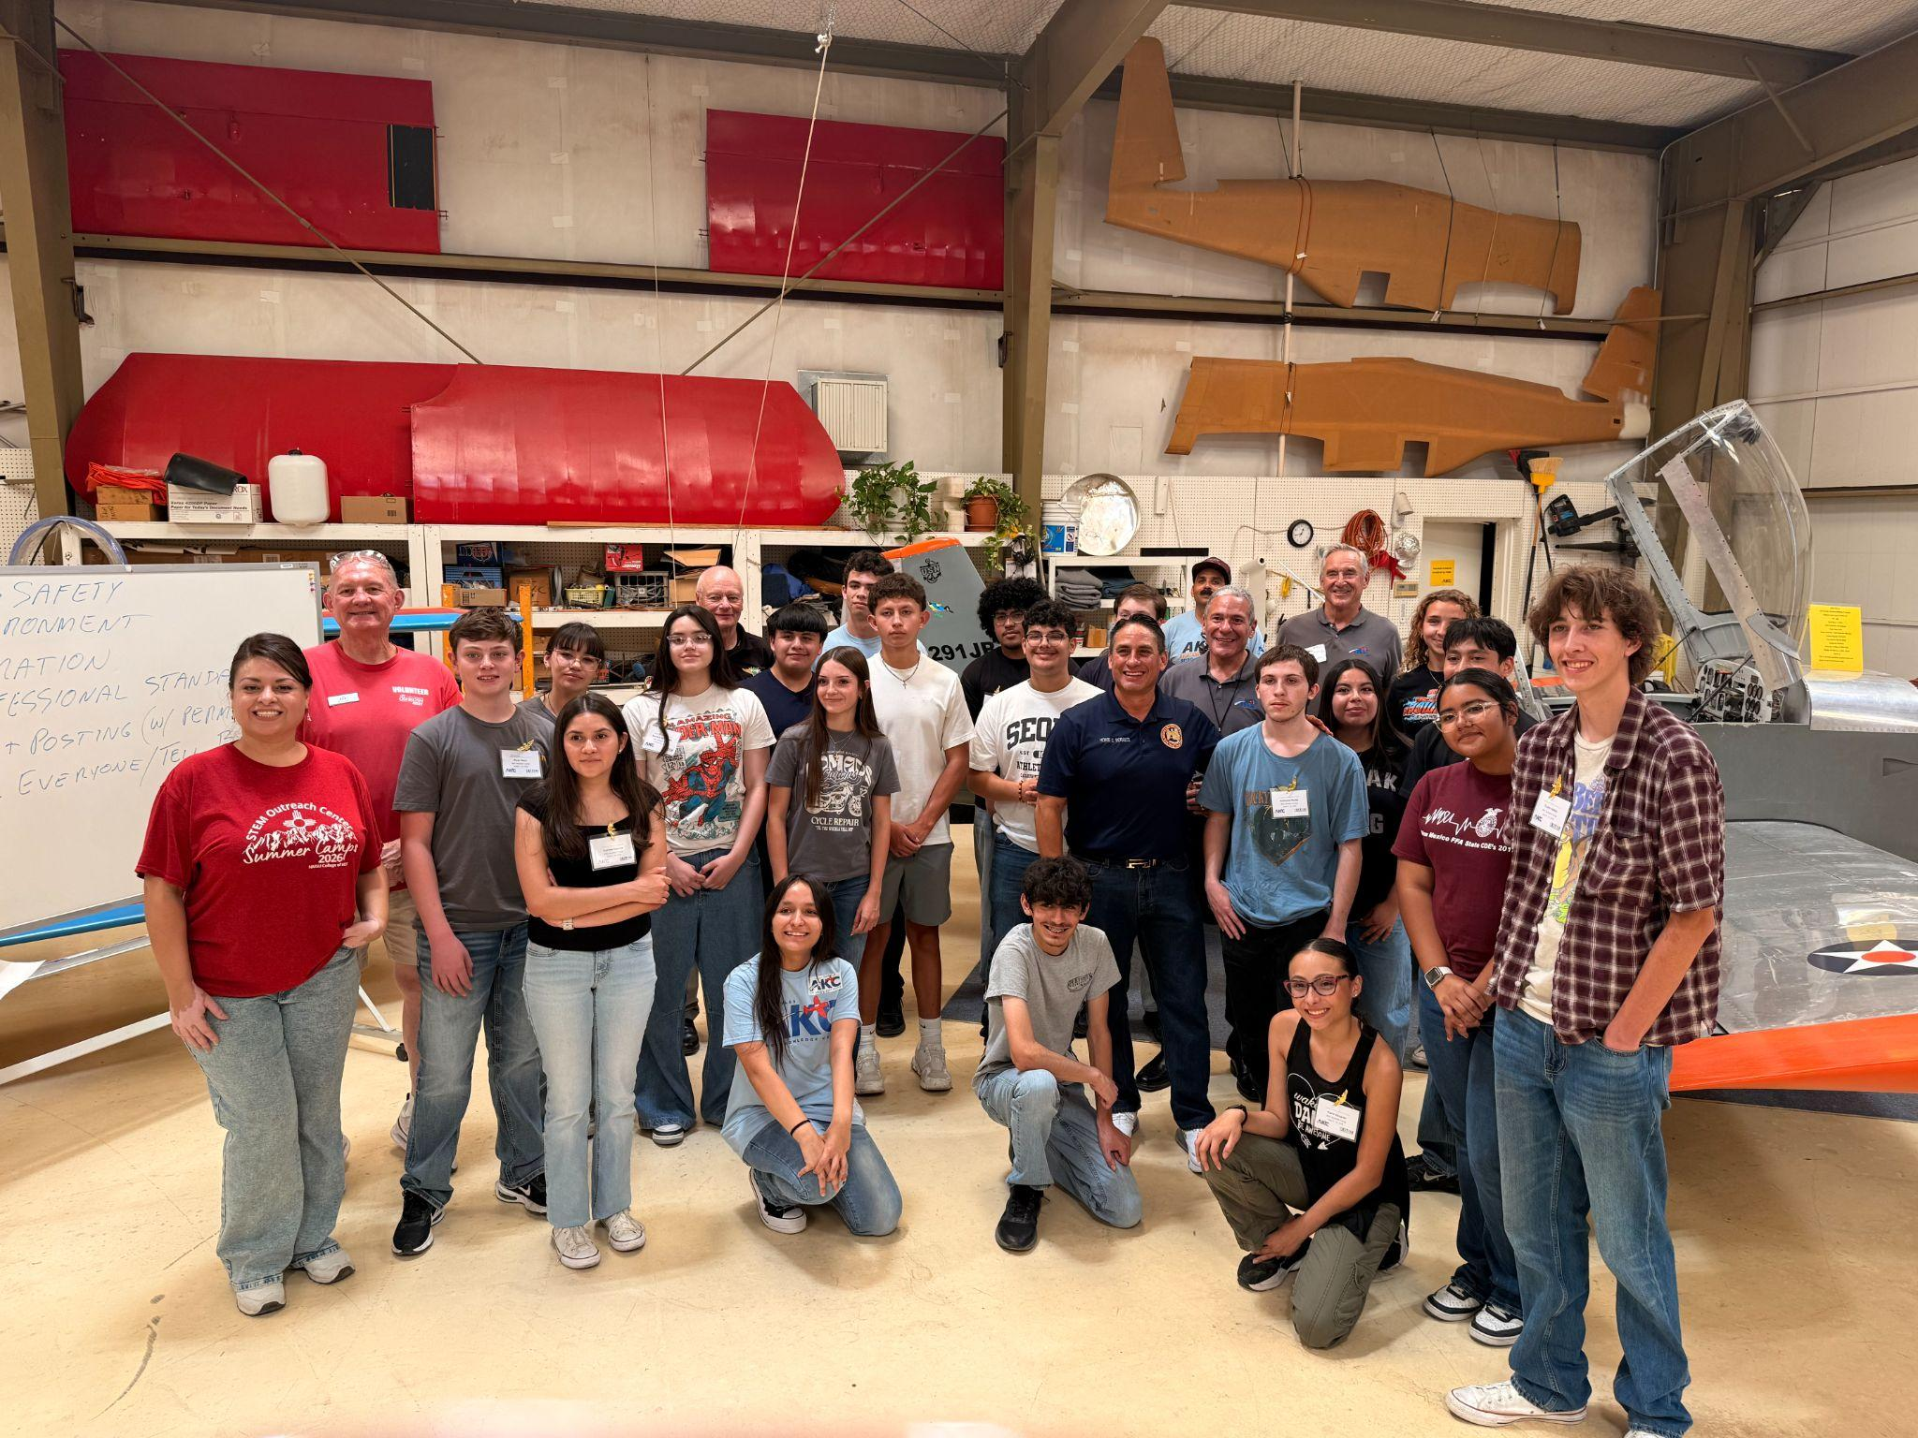
Internships were a key extension of the Network’s summer work-based learning strategy, exemplified by the Soules Aero Knowledge Center (AKC) Aviation Camp and Internship Program in Las Cruces. In 2026, 38 high school students each completed a paid, one-week aviation internship of 40 hours of structured learning at the AKC Hangar at Las Cruces International Airport and NMSU’s O’Donnell Hall, receiving a $250 stipend along with a formal certificate co-signed by Senator William P. Soules, AKC instructors, and the NM STEM Innovation Network. This documentation was intentionally designed to support portfolios, scholarships, college applications, and future employment, signaling that students had completed a rigorous, supervised experience aligned with real workforce expectations.
Aviation Summer Camp Interns with Lt. Gov. Howie Morales and Senator Soules, June 2026
The aviation internship combined rich technical content with explicit professional skill-building. Students engaged with airplane basics and flight fundamentals; aero forces and power plants; weather, navigation, and dead reckoning; welding and welding safety; flight simulation; pre- and post-flight safety and inspection; and aviation careers, including a Young Eagles flight experience and a site visit to Spaceport America. At the same time, the program emphasized punctuality, communication, teamwork, willingness to learn, and strict adherence to safety protocols. Together with the Network’s broader summer camps, these internships modeled how short, intensive, paid experiences can introduce students to high-demand STEM fields while building both technical fluency and the professional competencies valued by employers.

Community Outreach

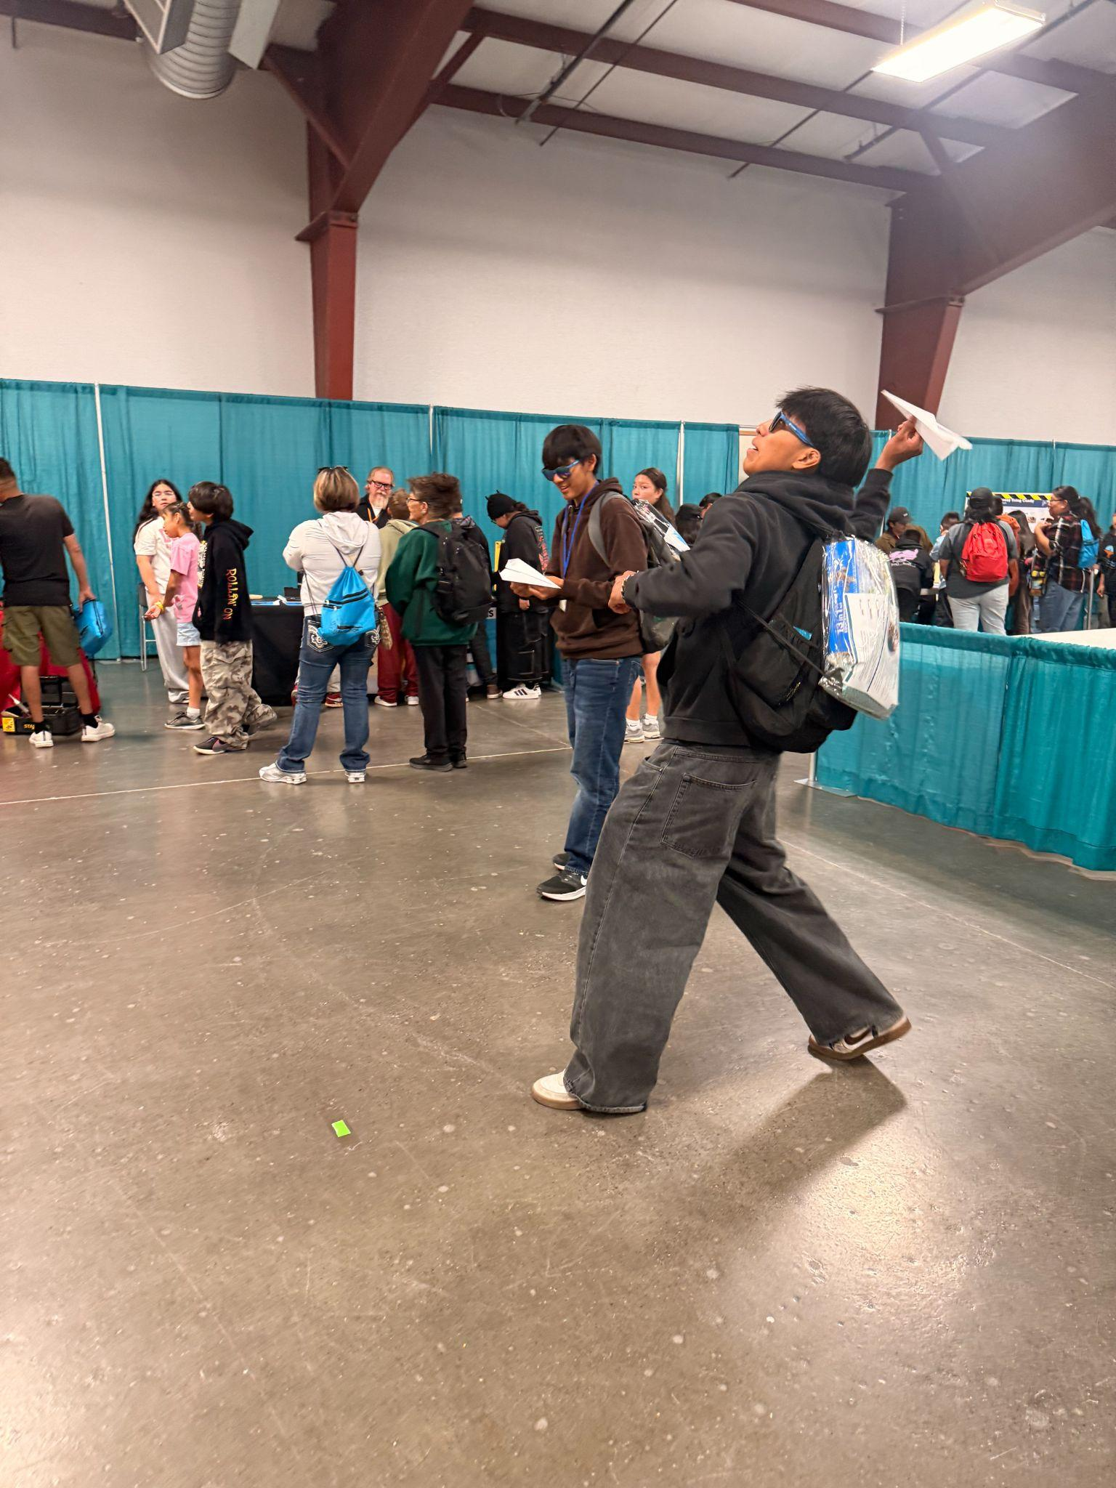
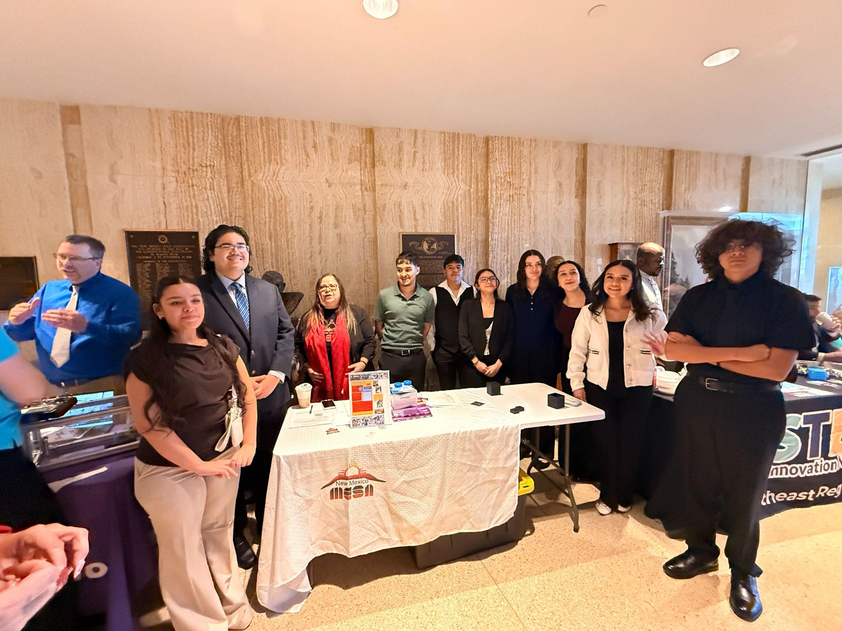
The New Mexico STEM Innovation Network engaged families and communities across the state through a wide range of public STEM events, festivals, library programs, and community partnerships that increased awareness of STEM learning opportunities and career pathways. Statewide outreach included events such as STEM Day at the Roundhouse, Farmington STEM Day, Fall in Love with STEAM, GilaFest, the Juneteenth Family Fun Fair, Community Health Fair, Tech Trek, Future Forge Summer of Science, DNA Day, MESA Day, NM MESA Regional Rallies, MESA USA, SiFT, the STEM Roadshow, Exploring the Possibilities, and numerous summer camps and local STEM celebrations. Regional Hubs further expanded community engagement by tailoring programming to local needs. The Southeast Hub partnered with public libraries to establish STEM Makerspaces and STEM Lending Libraries while hosting community STEM events for hundreds of students and families. The Central Hub collaborated with NM MESA to organize STEM and STEAM Days that attracted more than 500 participants. In northern New Mexico, the Northwest Hub partnered with Taos Twirl to develop the Environmental STEAM initiative, engaging approximately 600 fifth-grade students in exploring forest ecology, wildfire, ecosystem disturbance, and regeneration through classroom experiences that culminated in student artwork featured at the Paseo Arts Festival. Collectively, these outreach efforts directly engaged more than 2,500 students while extending their impact to thousands of additional family members, classmates, and educators, strengthening community awareness of STEM opportunities and inspiring continued engagement in STEM learning throughout New Mexico.
Farmington STEM Day,
April 2026
STEM Day at the Legislature with MESA Students,
Feb. 2026

OST Expansion Impact
Feedback from educators indicates that these summer and community initiatives met or exceeded their goals. Organizers reported high engagement and strong attendance, with students “excited to come to the summer programming” and particularly responsive to hands-on labs, outdoor and aviation activities, and projects that connected learning to real careers and college pathways. At New Mexico Tech, for example, the Network supported scholarships for 20 high school students to attend a one-credit STEM summer course, offering a first glimpse of college-level work; many more students enrolled on their own. An AP Biology bootcamp dramatically shifted student confidence, from 6.2 percent feeling prepared beforehand to 100 percent afterward, with participants citing the value of lab work, face-to-face instruction, and learning note-taking and lab protocols. Teacher-focused summer offerings, such as early numeracy institutes and Math Circles, were similarly well received, with educators describing the training as simple, practical, and immediately applicable to strengthening number sense, problem solving, and mathematical discourse.
Strong partnerships were central to this success and are poised to grow. Camps drew on sponsors and collaborators including Chevron, the McGary-Regan Foundation, NMJC Foundation, Woven Learning, Asombro Institute for Science Education, WNMU, NMSU, the Soules Aero-Knowledge Center, Spaceport America, local airports, and regional hubs that provided venues, stipends, and logistics. Organizers consistently affirmed that partners contributed as intended, providing materials, instructional expertise, and authentic STEM experiences, and all plan to continue and expand these collaborations in future summers. One notable outcome is the Network’s work with Soules Aero-Knowledge Center which led the partners to pursue an FAA Pilot Training Workforce Development grant that could reach over 2,000 students and 50 teachers through extended aviation internships and camps in 2026- 2028. Taken together, the Year 1 summer initiatives demonstrate how coordinated, partnership-driven programming can turn a few weeks of vacation into high-impact STEM, mathematics, and career exploration experiences that reverberate into the school year.

Connecting Education with Industry and Community Partners

Strengthening partnerships between education and industry was a central strategy of the Network in Year 1, with convenings and outreach grounded in three goals: identifying existing resources and initiatives, exploring where efforts overlap so they can be braided rather than duplicated, and surfacing effective education and industry partnership models that could be scaled to other regions of the state. Throughout the year, Network staff and leaders met with a wide range of industry and community partners, such as the Conrad Foundation, CNM, STEM Boomerang, Steady State Impact, the Math and Science Bureau, Computer Science Alliance, CSTA-NM, Great Minds in STEM, NMOGA, Thornburg, Girl Scouts, and others, to map where their work intersected with K-12 STEM priorities. These conversations helped clarify how partners could contribute to inquiry-based STEM learning, out-of-school enrichment, and career-connected pathways in ways that are responsive to local needs.
A key milestone was the April 9th Industry Roundtable, which brought together approximately 30 participants from across the education and workforce ecosystem to focus specifically on strengthening industry partnerships with K-12. In addition to members of the Executive Council, attendees included representatives from Intel, Junior Achievement Desert Southwest, Future Focus, the Department of Workforce Solutions, the College and Career Readiness Bureau, four-year institutions, and K-12 systems. The roundtable surfaced shared priorities such as expanding work-based learning, ensuring equitable access to STEM experiences, and aligning career readiness efforts with actual regional labor-market needs and generated concrete ideas for how industry partners can more consistently show up in classrooms, OST programs, and community STEM events.
Complementing this statewide work, each regional hub completed an initial asset-mapping process to build a comprehensive catalog of STEM activities, organizations, and resources in their areas, with a strong emphasis on identifying existing industry, nonprofit, and higher education partners. The resulting maps include organizations like Twirl Taos, STEM Santa Fe, Environmental Education of New Mexico, NM MESA, the Northern NM STEAM Coalition, Taos Pueblo Education & Training, El Raton Media Works, the Society of Hispanic Professional Engineers, Asombro Institute, Explora, New Mexico PBS, multiple public libraries and museums, higher education partners (e.g., CNM, ENMU-Roswell, WNMU, University of the Southwest), and many rural school districts. In southeastern and southwestern New Mexico in particular, hubs documented robust engagement from health systems, foundations, and the energy sector, including Chevron, Conoco Phillips, Devon Energy, Mewbourne Oil, NMOGA, and local hospitals, alongside youth-serving organizations like Boys & Girls Clubs and Big Brothers Big Sisters.
Taken together, these statewide convenings and regional asset-mapping efforts established the foundation for a more coordinated, scalable approach to education and industry collaboration in STEM. By making visible the breadth of existing partners, from local soil and water conservation districts and outdoor schools to tech firms, universities, museums, and major employers, the Network has begun to clarify where strong models already exist and where new connections are needed. This groundwork positions the STEM Innovation Network to move from relationship-building to implementation in future years, aligning mini-grants, OST programs, and classroom initiatives with concrete industry partnerships that can offer students meaningful exposure to careers, authentic problem-solving experiences, and clearer pathways into New Mexico’s high-wage, high-demand STEM fields.

Supporting Statewide Competitions

The NM STEM Innovation Network played an expanded role in coordinating and promoting statewide STEM competitions, using these events as powerful vehicles for authentic, project-based learning. In 2026, the Network deepened its partnership with the Los Alamos National Laboratory (LANL) Foundation to support the New Mexico Governor’s STEM Challenge & Showcase, with a deliberate focus on recruiting schools and districts that had not previously participated. Through targeted outreach, information sessions, and direct technical assistance, the Network helped demystify the competition for new schools, especially in rural, Tribal, and underrepresented communities, and supported teachers in understanding timelines, expectations, and how to integrate the Challenge into existing coursework or OST programs. For the 2026 competition, approximately 800 students, 200 teacher sponsors, and 50 industry partners participated.
Building on this groundwork, the NM STEM Innovation Network is now serving as the lead organizer for the upcoming NM Governor’s STEM Challenge & Showcase cycle. In this role, the Network is coordinating statewide communication, registration, and teacher support, and is working closely with business, industry, and higher education partners to ensure the challenge prompt is aligned with real-world STEM needs in New Mexico. The Network is also designing supports such as virtual Q&A sessions, resource guides, and office hours to help first-time schools submit competitive projects. This leadership position not only expands student access to a high-profile statewide competition, but also positions the Challenge as a central, equity-focused pathway into STEM careers and postsecondary opportunities.
In addition to the Governor’s STEM Challenge, the Network amplified awareness and engagement in other flagship statewide competitions, including Miner Mayhem Robot Combat Tournament and the New Mexico Supercomputing Challenge. Through its regional hubs, newsletters, and direct educator networks, the Network promoted Miner Mayhem as a way for students to explore engineering design, robotics, and problem solving connected to New Mexico’s mining and natural resources sectors. The Network’s outreach emphasized how schools could use existing robotics clubs or OST programs as a launchpad for participation, lowering the barrier to entry for small or rural schools that might not otherwise consider a statewide competition.
Similarly, the Network worked with partners of the New Mexico Supercomputing Challenge to encourage broader participation in computational science and high-performance computing projects. By sharing competition timelines and mentoring opportunities, and by connecting interested teachers with experienced coaches and university partners, the Network helped more schools see the Supercomputing Challenge as an attainable and valuable experience. Across the Governor’s STEM Challenge, Miner Mayhem Robot Combat Tournament, and the Supercomputing Challenge, the Network’s role has been to recruit new schools, clarify expectations, and provide practical support so that students from every region of the state can engage in rigorous, real-world STEM problem solving.

In addition to the three competitions listed above, the Network provided staffing support and funding for transportation and registration fees for other STEM-based competitions such as TSA and BEST Robotics.
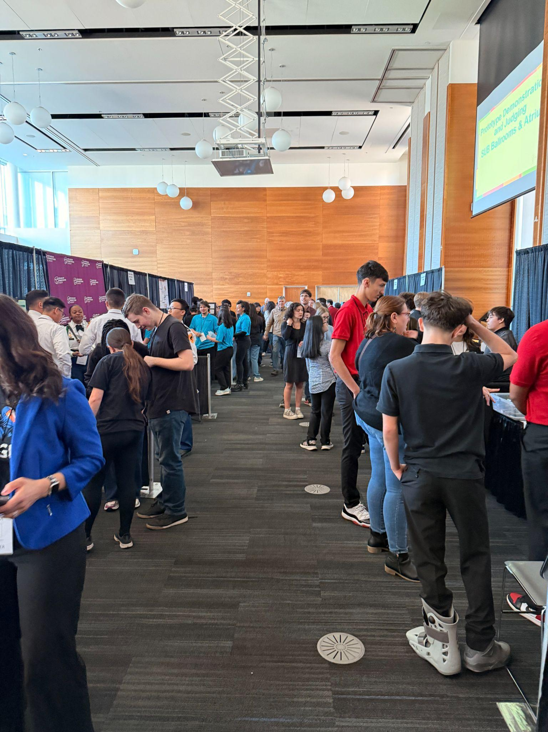
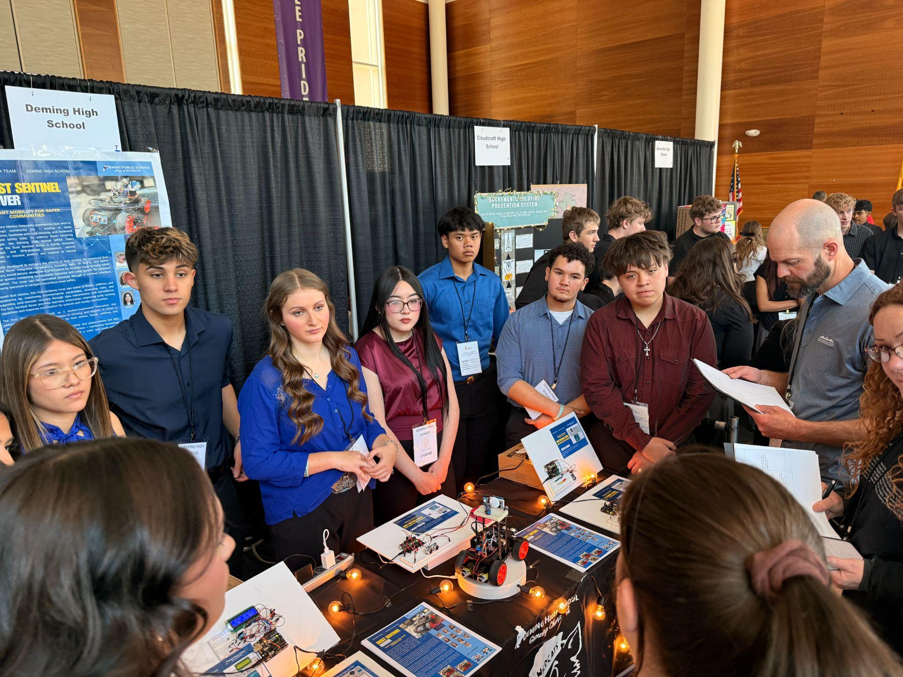
2026 NM Governor’s STEM Challenge,
New Mexico Highlands University

4. Funding – Budget Expenditures and Expansion

State Appropriation to Establish a STEM Innovation Network for New Mexico

The New Mexico STEM Innovation Network is primarily funded through a $3 million state legislative appropriation to the New Mexico Public Education Department (PED) in Fiscal Year 2026 (FY26) to establish a statewide science, technology, engineering, and mathematics (STEM) network. These funds were distributed to the New Mexico State University Institute for Excellence in Math and Science Education (IEMSE) through an Intergovernmental Agreement (IGA) with PED. Table 1 summarizes how the legislative appropriation was allocated and expended during FY26.
Table 1: Legislative Funding for the Network
Category | Description | Budgeted | Actual Expenditures
Principal Hub | Staff Salaries (5 FTE) and Fringe (40%) :  - Executive Director (0.8 FTE)  - Co-Director for Professional Learning (0.8 FTE)  - Partnership Development Specialist (0.8 FTE)  - STEM OST Specialist (0.6 FTE)  - Faculty Support for Data Collection (0.2)  - Accounting Specialists (1.0 FTE)  - Logistics Coordinator (0.5 FTE)  - Admin Assistant (0.5 FTE)  - Graduate Assistant (0.5 FTE) | $700,000 | $548,015
Operational Costs | - Executive Council Venue and Travel Costs  - Staff Travel  - Office materials, supplies, equipment  - Graduate Student Fees  - Business Meals  - Office Space and Venue Rental  - Printing | $85,000 | $99,859
Regional Hub Subawards | Regional Hubs  Central Hub:  - Explora (Fiscal Lead), $70k  - NM Tech, $54k  - R4Creating, $126k (includes Director salary)  Northeast Hub: NMHU, $250k  Northwest Hub: San Juan College, $250k  Southeast Hub: REC #6, $250k  Southwest Hub:  - WNMU, Lead, $139k  - SWREC, $110k | $1,250,000 | $1,158,470
Educator Professional Learning | Expenses include training allowances/stipends/scholarships, travel reimbursement, and instructional supplies for educators to participate in STEM-based professional learning and implement Summer STEM Camps. Funds also include mini-grant expenses for three recipients unable to use the reimbursement system. | $190,000 | $252,378
Mini-grant Awards | 23 small grants awards ranging from $5k-15k | $260,000 | $230,000
Professional Service Agreements for Statewide Conferences | - Future Focused Education, Industry Guidebook ($15k)  - Explora: STEM in a Box OST ($30k)  - NMOST Spring State Conference ($20k)  - CES Leadership Conference ($18k)  - Southwest Decision Resources Facilitation ($8k)  - Quill Web Design and Maintenance ($19,800)  - EnvisionEdPlus State Network Consultants ($15k) | $100,000 | $125,800
Statewide STEM Competitions | - Super Computing Challenge: ($200k)  - NM Tech: MechE Miner Mayhem ($54k)  - NMOST Women in STEM Scholarships ($7k)  - Governor’s STEM Challenge ($40k)  - R4C:BEST Robotics National Registration ($4k)  - NM Tech Summer UBMS Scholarships for Alamo Reservation ($14k) | $300,000 | $294,000
Research and Evaluation | Data Collection, Asset Mapping | $50,000 | $16,000
NMSU Indirect Costs | Indirect Cost was capped at 8% by the PED. | $146,986 | $139,911
 | Total | $3,000,000 | $2,864,433
Note: Funding for Fiscal Year 2027 was allocated in the 2026 Legislative Session in House Bill 2, flowing through the PED.

Additional Funding Requests to Support Network Priorities

In Year 1, newly established Regional Hubs were encouraged to seek additional funding to support the three priority areas of the network. Table 2 provides a list of grant proposals that were submitted in Spring/Summer 2026 on behalf of the STEM Innovation Network.
Table 2: Funding Proposals Submitted on behalf of the STEM Innovation Network
Submitting Agency | Funder | Purpose | Funds Requested | Funds Received
SW Regional Hub | NM PED Community School Bureau | Expand OST program to rural communities | $612,720 | $330,000
SE Regional Hub | NM PED Community School Bureau | Expand OST program to rural communities | $617,076 | $260,000
STEM Outreach Center at NMSU in partnership with Principal and SW Regional Hubs | 21st Century Community Learning Centers, US Dept. of Education/NM PED | Expand OST program to serve Deming Schools and Gadsden High Schools | $1,500,000  (expansion funds requested) | $1,100,000
SW Hub in partnership with MC² | Southwest Regional Education Cooperative | Support Secondary Math Teacher Professional Learning | $231,225 | Not funded
Principal Hub in partnerships with Soules Aero-Knowledge Center | Federal Aviation Association | Aviation Workforce Development and aviation internships for 80 high school students | $998,571 | TBD

5. Reflections from Regional Hub Directors

Regional Hub Directors were asked to provide reflections of the highlights and lessons learned from their work in their respective regions. Below are reflections from each Regional Director.

Southwest Hub (Tanya Rivers)

The Southwest STEM Hub was established in late January 2026 and immediately began planning summer Out-of-School Time (OST) and teacher professional learning opportunities. To date, the Hub has helped organize nine summer OST activities, supported teachers in attending mathematics professional learning, and provided training for educators facilitating summer programming. Much of the Hub's contribution has been providing funding for materials and stipends while assisting organizations with planning, coordinating, and promoting these events. These efforts have expanded STEM learning opportunities for students, strengthened STEM literacy and skill development across the region, and fostered strong relationships with Silver Consolidated Elementary School principals and teachers that will continue to support professional learning opportunities in the coming year. The Hub has also worked intentionally to establish name recognition throughout the community and collaborated with several schools and community organizations to submit a PED OST grant proposal, with tremendous support from the Principal Hub. Another highlight was the Environmental Education of New Mexico (EENM) Outdoor Learning professional development, which generated more than 70 applications for 15 available slots (ultimately serving 16 teachers). Participants were highly engaged, creating a strong foundation for continued outreach through future professional learning and funding opportunities. In addition, equipment was purchased to establish a STEMinNM Southwest Hub Education Workshop within the Math and Computer Science Department at Western New Mexico University, with the space expected to open this fall. Throughout these efforts, the Hub has learned the importance of understanding the unique culture of schools throughout the region as well as the purchasing and reimbursement processes of different partner organizations. The partnership with the Southwest Regional Education Cooperative has been instrumental in processing stipends, travel reimbursements, purchasing supplies, and promoting Hub activities throughout the region. Looking ahead, the Hub is excited to continue building these partnerships while pursuing new opportunities, including a collaborative Western New Mexico University–New Mexico Tech initiative to strengthen STEM career pathways connected to opportunities at Los Alamos National Laboratory.

Lessons Learned: The Southwest STEM Hub experienced several challenges during its first few months of operation, including learning how to effectively utilize funding within grant constraints, navigating purchasing and reimbursement processes, building trust and relationships with community partners, and accomplishing ambitious goals with a small, part-time staff. A significant amount of time was devoted to understanding the requirements of the Hub's fiscal agents, developing efficient planning and event management systems, and improving methods for collecting and tracking program data. These experiences reinforced the importance of spending funds early, planning events well in advance through an annual calendar, and streamlining purchasing and budgeting processes to improve efficiency in the coming year. Building new partnerships also required considerable effort, particularly with busy educators and community organizations, but these investments have laid a strong foundation for future collaboration. Next year, the Hub plans to deepen relationships with local schools and existing partners, such as Asombro, while expanding collaborations with museums, recreation centers, families, and other organizations that can strengthen Out-of-School Time and after-school programming. The Hub also intends to continue advancing STEM career pathway partnerships with organizations such as Western New Mexico University, New Mexico Tech, and Los Alamos National Laboratory as workforce development initiatives continue to evolve. While organizational transitions at Western New Mexico University presented additional challenges during the Hub's inaugural year, recent leadership changes and increased institutional stability provide an opportunity to further integrate STEMinNM into the university's strategic priorities. Overall, the lessons learned during these first months have provided valuable experience that will strengthen planning, operations, partnership development, and program implementation in the coming year.

Southeast Hub (Devon Fite)

Year 1 of the New Mexico STEM Innovation Network Southeast Regional Hub focused on building strong regional partnerships, increasing access to STEM learning opportunities, and establishing sustainable infrastructure to support future growth. One of the most significant accomplishments was the development of dedicated STEM learning spaces and community-based programming throughout the region. Through collaboration with schools, community organizations, higher education partners, industry representatives, and out-of-school-time providers, the Southeast Region expanded opportunities for youth and families to engage in meaningful STEM experiences. Programming included hands-on STEM activities, family engagement events, workforce awareness opportunities, literacy-integrated STEM experiences, and community outreach efforts designed to reach historically underserved populations.

The region also successfully established Lending Libraries and resource-sharing opportunities to increase access to STEM materials beyond traditional classroom settings. These resources, combined with dedicated learning spaces, created consistent points of engagement for students, families, and educators throughout the year. Regional partners demonstrated a strong willingness to collaborate, resulting in increased awareness of STEM pathways, stronger connections between community organizations, and greater participation in STEM-related activities. The work completed during Year 1 laid a solid foundation for long-term sustainability and helped strengthen the STEM ecosystem across Southeast New Mexico.

Lessons Learned: Year 1 reinforced the importance of relationship-building, communication, and regional coordination. While significant progress was made, challenges included serving a large geographic region, balancing the needs of multiple communities, and ensuring that partners had sufficient capacity and awareness to fully engage in STEM opportunities. Another lesson learned was that establishing new partnerships and programs often requires more time than anticipated, particularly when coordinating across school districts, community organizations, and industry partners. The region also identified a need for more structured data collection processes to better capture participation, outcomes, and long-term impact.
To address these challenges in Year 2, the Southeast Regional Hub will prioritize strengthening partner engagement through more intentional communication, clearer collaboration structures, and expanded outreach efforts. The region will continue growing the use of dedicated STEM learning spaces and Lending Libraries while increasing support for out-of-school-time programming and workforce-connected STEM experiences. Additional focus will be placed on connecting K–12 students with industry partners, expanding access to STEM opportunities in rural and underserved communities, and improving data collection practices to better measure impact. These lessons learned have helped identify opportunities for deeper regional collaboration and will guide strategic investments that increase access, sustainability, and meaningful STEM engagement across Southeast New Mexico.
Central Hub

Central Hub (Bob Gruenig)

During Year 1, the Central Region Hub (“Hub”) successfully established a collaborative partnership (“Partnership”) that brought together the complementary strengths of Explora, New Mexico Tech, and R4Creating to advance the Network’s three core priorities: professional development, out-of-school-time (“OST”) STEM learning, and education-to-industry connectivity. The Partnership successfully launched and coordinated activities across all three priority areas throughout the region, including rural and tribal areas. Professional development offerings included educator-focused opportunities such as Inspire Math Confidence in Socorro and Introduction to Makerspaces & Renewable Energy in Albuquerque. OST efforts provided inquiry-driven STEM learning experiences and supported student engagement through events such as STEM Day at Valencia High School, the VEX IQ State Championship in Rio Rancho, and Miner Mayhem in Socorro. Industry engagement efforts expanded relationships with employers, economic development organizations, and community leaders through activities such as Sandoval Economic Alliance breakfast meetings and a Robotics Happy Hour, which focused on building stronger industry partnerships.

A significant accomplishment of Year 1 for the Hub was the establishment of a regional STEM ecosystem framework that connected educators, community organizations, and industry partners around a common vision for improving STEM access and workforce readiness. The Hub also completed substantial outreach and relationship-building activities that increased awareness of the Network throughout the region; helped identify existing STEM assets, opportunities for collaboration, and gaps in service; and brought in additional partners to support this effort. By leveraging New Mexico Tech’s capacity for educator professional development, Explora’s expertise in informal STEM education and convening, and R4Creating’s experience in robotics, mentorship, and industry engagement, the Partnership created a strong foundation for future growth and demonstrated the value of a coordinated regional approach to STEM education and workforce development.

Lessons Learned: One of the most important lessons learned during Year 1 was that the Hub’s organizational structure created operational complexities that affected efficiency and decision-making. While Explora served as the Hub’s fiscal agent, separate subawards (“sub-contracts”) were issued to Explora, New Mexico Tech, and R4Creating to lead activities aligned with the Network’s three core priorities. In addition, a separate sub-contract arrangement between Explora and R4Creating funded the Central Hub Director position, which was housed at R4Creating. Although this structure enabled each partner to contribute its unique expertise, it also created challenges related to coordination, reporting, communication, budgeting, and decision-making authority. Year 1 also highlighted the importance of moving beyond relationship-building toward deeper implementation and measurable outcomes. The Hub found that educators, community organizations, and industry partners were enthusiastic about collaboration but often faced competing priorities and limited time to engage.
[Due to the complexities of separate sub awards in Year 1], the Principal Hub issued a Request for Proposals to contract with a single entity to manage the Hub, which shall include elimination of the Partnership’s sub-contracts focused on the Network’s three priorities. For Year 2, the current Hub strongly expects that the Partnership which provided valuable Network-related services during Year 1 will dissolve and that it may be some time until the Central Hub is able to provide any such services in Year 2.

Northwest Hub (Alyssa Wagner)

Our Hub participated in and facilitated numerous activities. Our offerings in Year 1 include:
- Regional Science Fair
- Neuroscience Workshop
- FMS STEM Festival
- Geo Stats teacher training
- Numeracy Foundations teacher training
- Math Circles teacher training
- Upward Bound Summer Academy

We’ve also begun building our Resource Library, a collection of STEM kits, equipment, and resources that K-12 teachers can check out and use in their classrooms. Ex: our TRIO Upward Bound program is borrowing an Ozobots Ari classroom kit for their Summer Academy.

Lessons Learned: As we move into Year 2, we look forward to deepening existing partnerships and fostering new ones, including with industry. Lessons learned from Year 1 to implement in Year 2 include:
- Knowledge of SJC’s internal policies and procedures (ex: process for securing lodging for PD opportunities using grant funds)
- Importance of digital presence
  - Develop NW Hub’s webpage on the STEM Innovation Network website
  - Build a NW Hub webpage on SJC’s website
  - Post PD opportunities to SJC’s social media accounts

Northeast Regional Hub (Clint Weckerly)

Year 1 established a strong foundation for the Northeast Regional Hub and demonstrated the value of regionally driven STEM partnerships. Through collaboration with school districts, community organizations, higher education partners, and informal STEM providers, the Hub supported a wide range of professional learning opportunities, out-of-school-time programs, and student-centered STEM experiences across northern New Mexico. Key partnerships included NM MESA, STEM Santa Fe, Twirl Taos, Española GloveWorks, Environmental Education of New Mexico, Tierra y Montes Soil and Water Conservation District, and numerous school districts and educators throughout the region. Collectively, these efforts expanded access to high-quality STEM learning opportunities for hundreds of students and educators while strengthening connections among organizations that share a commitment to educational opportunity and workforce development.

Equally important, Year 1 allowed the Hub to establish itself as a convener and connector. By leveraging existing relationships and creating new ones, the Hub helped align partners around shared goals while identifying opportunities for collaboration that may not otherwise have emerged. The development of the Northern New Mexico STEAM Coalition, growing relationships with industry and community partners, and increased coordination among educational organizations have positioned the region for even greater collective impact moving forward. The year demonstrated that a regional approach can successfully amplify existing efforts while creating new pathways for STEM engagement, educator support, and student success.

Lessons Learned: One of the most important lessons from Year 1 was the value of investing time in relationship-building before focusing on program expansion. The diversity of communities, organizations, and educational contexts across northeastern New Mexico requires an approach that prioritizes trust, communication, and responsiveness to local needs. While this relationship-building work takes time, it proved essential for identifying meaningful partnership opportunities and ensuring that regional activities reflected the priorities of educators, students, and community stakeholders. Year 1 also highlighted the importance of balancing immediate programmatic opportunities with long-term strategic planning, particularly in a region where many organizations operate with limited capacity and resources.

Looking ahead to Year 2, the Hub plans to build upon the partnerships and momentum established during its inaugural year while increasing focus on sustainability, coordination, and measurable impact. Priorities will include expanding educator professional learning opportunities, strengthening support for out-of-school-time STEM programming, deepening engagement with rural and underserved communities, and leveraging regional partnerships to reduce duplication of effort and maximize available resources. The Hub will also continue developing systems for documenting impact, communicating opportunities across partner organizations, and identifying collaborative projects that advance shared regional goals. These strategies will help ensure that Year 2 moves beyond relationship-building into deeper, more coordinated implementation that benefits both educators and students across northeastern New Mexico.
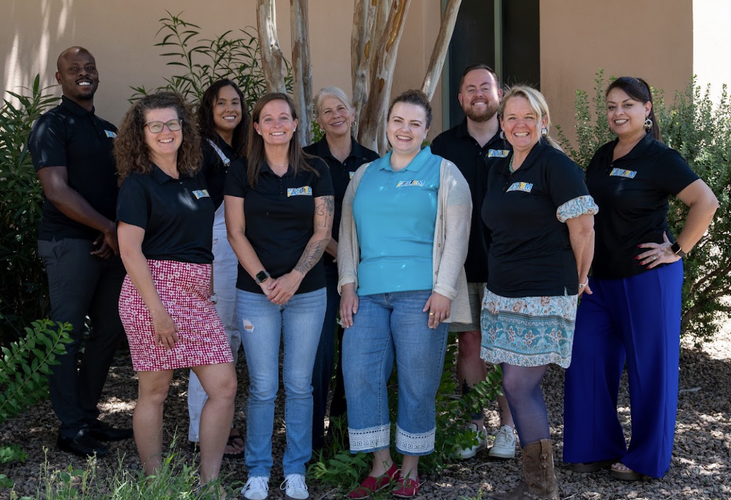
NM STEM Innovation Network Principal and Regional Hub Directors, July 2026

