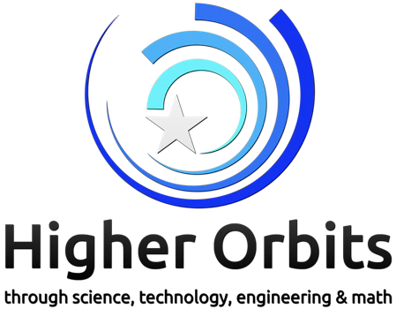
Go For Launch! Albuquerque Brings Spaceflight, STEM and Astronaut Mentorship to New Mexico
Higher Orbits will bring its nationally recognized Go For Launch! program to Albuquerque November 7–8, giving students in grades 8–12 an opportunity to experience STEM in a truly out-of-this-world way—on National STEM Day weekend.
Hosted at the NewSpace Nexus Launchpad, Go For Launch! uses space exploration as a platform for students to develop skills in science, technology, engineering and mathematics while also strengthening teamwork, communication, leadership, creativity and problem-solving. Over two days, students will work alongside aerospace professionals and former NASA astronaut Greg “Box” Johnson, designing a spaceflight experiment that could ultimately be selected to fly to space.
Johnson, a retired U.S. Air Force Colonel and veteran of two Space Shuttle missions, has flown more than 50 different aircraft and brings decades of experience in aviation, engineering, test piloting and human spaceflight. He has also been a longtime mentor and supporter of Higher Orbits and its students. His message to students is simple: space careers begin with pursuing what you love and developing the skills to do it well.
The Albuquerque event is part of Higher Orbits’ 10th anniversary year of Go For Launch!, a program that has engaged thousands of students across the country and helped send 24 student-designed experiments into space. The program gives students more than an introduction to STEM; it provides direct access to mentors, authentic problem-solving experiences and a chance to see themselves as future members of the space and STEM workforce.
For New Mexico, a state with a growing aerospace and space technology ecosystem, Go For Launch! offers students a unique opportunity to connect their classroom learning to real-world possibilities, and to celebrate National STEM Day by reaching for something far beyond Earth.
Go For Launch! Albuquerque
📅 November 7–8, 2026
📍 NewSpace Nexus Launchpad, Albuquerque
👩‍🚀 Featuring former NASA astronaut Greg “Box” Johnson
🎓 Open to students in grades 8–12
🖥️Registration- https://higherorbits.org/events/go-for-launch-albuquerque-2026/

